Investment:

Money: Rs 1280

Time:

Start date: 6/9/2018

Queries:

* 1. What is rune type?
  2. How are strings created internally in golang?
  3. Concurrency vs Parallelism?
  4. Printf vs Println

Important resources:

* 1. How channels work ? - <https://www.youtube.com/watch?v=KBZlN0izeiY&t=781s>

To cover:

 Basic Syntax

 Variables

 Strings

 Prune

 Data structures

 Array

 Slice

 Map

 Struct

 Interface

 Pointers in go

 Go concurrency

 Go dependency Mgmt -

Resources:

* 1. Udemy video
  2. <https://golang.org/doc/effective_go.html>
  3. <https://talks.golang.org/2012/splash.article>
  4. <https://medium.com/@tjholowaychuk/farewell-node-js-4ba9e7f3e52b>
  5. <https://blog.golang.org/>
  6. <https://github.com/ardanlabs/gotraining>

Golang:

-----------------------------------------------------------

* 1. Why use golang?
  2. Created by google.
  3. Performance
  4. Can take advantage of multiple cores.
  5. Concurrent programming made easy.
  6. Complied language.
  7. Can run really well in network environment.
  8. Good garbage collection.
  9. Clean syntax
  10. Powerful standard library.
  11. Portable: compiled

---------------------------------------------------------------

Notes:

* 1. Semi colons are not required. Inserted automatically by the compiler.
  2. First line should be a package declaration.
  3. Followed by import statement to use code written by other people.
  4. Golang.org has only the standard library.
  5. Dodoc.org has both standard library and those written by others (third party)

32/64 Bit processor means how many 0s and 1s the computer can process at one time.

* 1. For using third package library we need to provide the fully qualified name import statement.
  2. We need to main function in the code in order to run it and make it executable.

---------------------------------------------------------------

Organizing Go code:

* 1. **Package Names:**

Keep package names short and meaningful.

Don't use underscores, they make package names long.

io/ioutil not io/util

suffixarray not suffix_array

**Don't overgeneralize. A util package could be anything.**

**The name of a package is part of its type and function names.**

**On its own, type Buffer is ambiguous. But users see:**

buf := new(bytes.Buffer)

Choose package names carefully.

Choose good names for users.

* 1. GOPATH:

The GOPATH environment variable tells the Go tool where your workspace is located.

go get github.com/dsymonds/fixhub/cmd/fixhub

**The go get command fetches source repositories from the internet and places them in your workspace.**

Package paths matter to the Go tool. Using "github.com/..."

means the tool knows how to fetch your repository.

go install github.com/dsymonds/fixhub/cmd/fixhub

**The go install command builds a binary and places it in $GOPATH/bin/fixhub.**

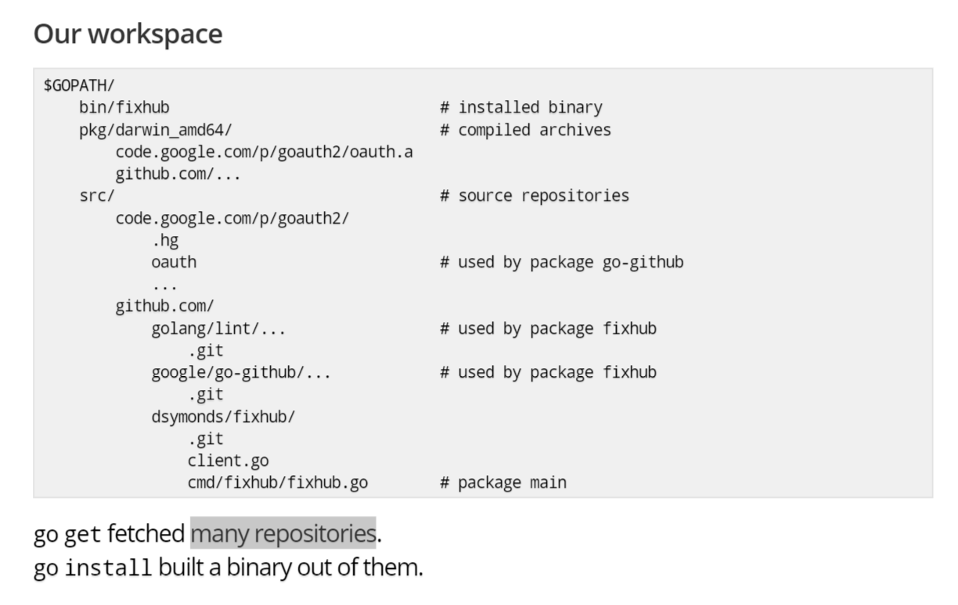

Using this configuration, we won't require any configuration for makefile or build file.

About go:

* 1. Go is a statically typed language

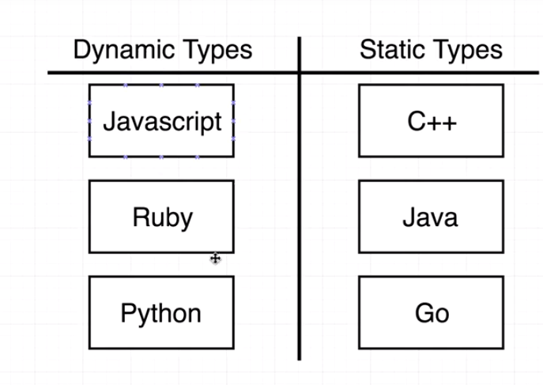

Once a variable is declared for a particular type. We can't change the variable value with a different type.

* 1. Some basic Go Types:

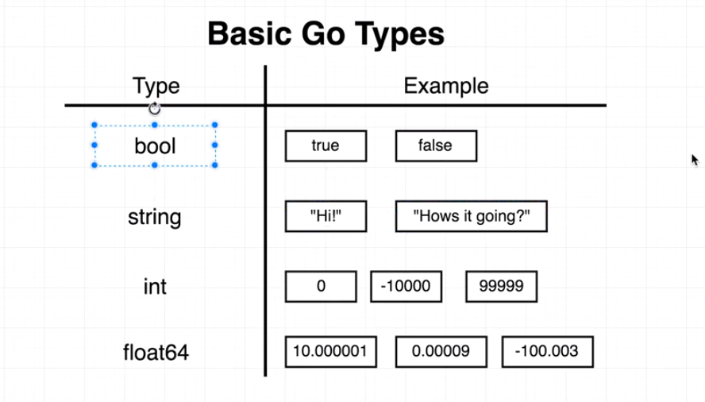

-------------------------------------------------------------

Go workspace:

* 1. All the projects in golang should live in the same workspace.
  2. When installing go we get 'go' folder created in the home directory (we can rename this) and this should act as our workspace.
  3. Inside workspace, we need to add 'src' folder which will contain all our projects.

* 1. Structure we can use with golang projects:

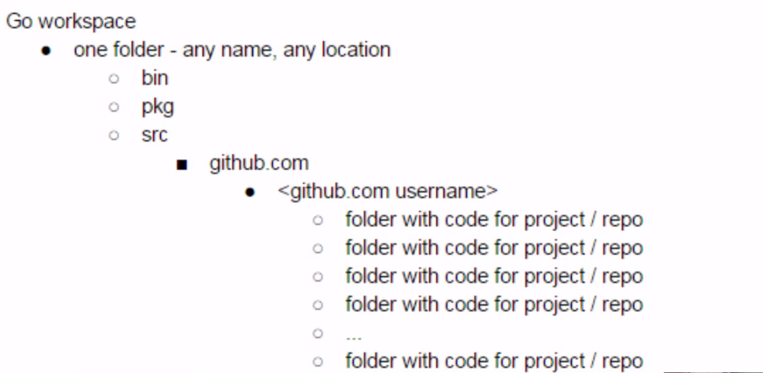

* 1. All go projects goes inside 'src' folder.
  2. bin folder will contain all the binaries.
  3. 'pkg' folder will contain all the imported third party packages.
  4. We need to create a workspace and make it point to the GoPath environment variable.
  5. We need to make sure the GoRoot env variable is pointing to where golang is installed.

-----------------------------------------------------------------

Configuring environment variables on Windows:

-----------------------------------------------------------------

Language fundamentals:

* 1. **Packages**:
  2. To organize code.
  3. To group together code with similar purpose.

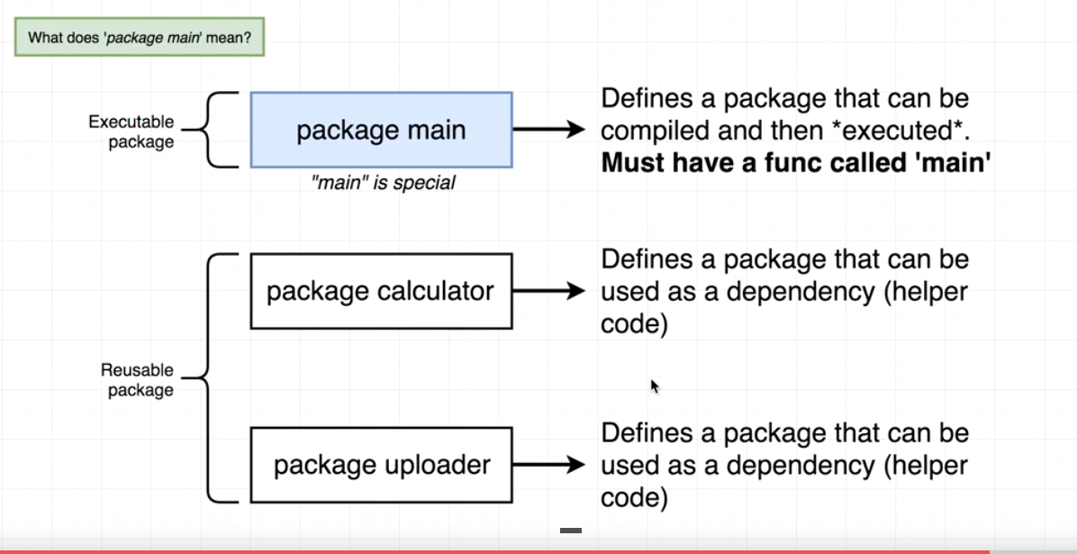

* 1. The folder name and the package declarations of the files inside the package should be same.

* 1. Something in one file of the package is accessible to other files within the same package.
  2. **Identifiers with lowercase name are not exported outside the package and hence can't be used outside. Also called invisible identifiers.**
  3. **Identifiers with uppercase name can be used outside the package as well. Also called visible identifiers.**
  4. So ideally if we don't want anyone to directly modify the variables, we create them with small name, and then create a function with capital name that has access to that variable. This is similar to getter and setter in other languages.
  5. An exported function (in caps) can call the unexported function (small case) within the package.

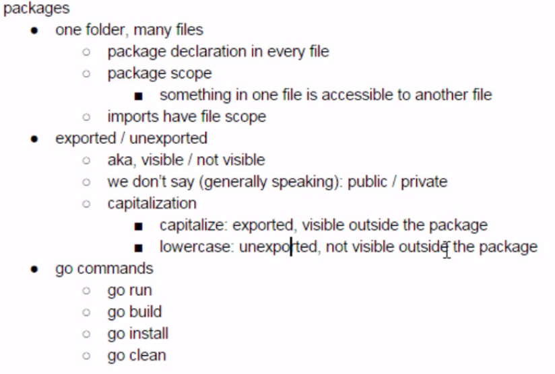

- Import Statements:

* 1. Go file organization:

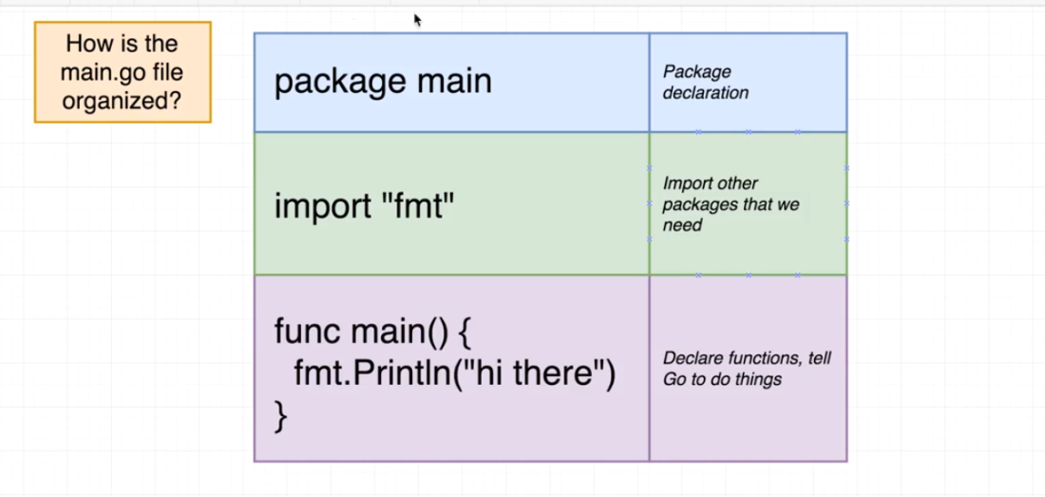

* 1. **Go command line:**

Type go in terminal to see some go command line options.

Detailed info can be found in - <https://golang.org/cmd/go/>

- go help <command> : gives details about the command.

* 1. go version: to know the version.
  2. **go get** : to install some 3rd party packages
  3. go get -u <package name> to update the package.
  4. **go env**: gets all the environment variables specific to golang.
  5. go fmt: to format our go code.
  6. **go run <filename>:** to run an executable file, that is, the file having main method. If file does not have main method, then it will not run.
  7. **go build** : creates an executable if we run it against a folder that has an executable (a go file with main function).
  8. go clean : cleans the builds that are present.
  9. **go instal**l : installs the exe file into 'bin' folder. Then we can run it from anywhere inside our computer as env variable is set up till bin.

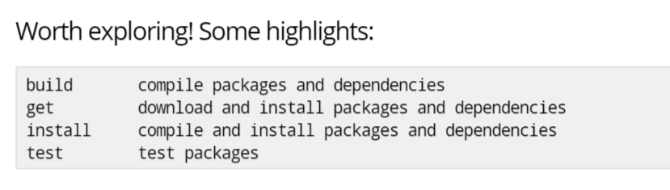

Go Get:

* 1. go get always fetches the latest code, even if your build breaks. That's fine when developing. It's not fine when releasing.

We need other tools.

How to do version of dependencies?

* 1. Naming:

Use the shortest name that carries the right amount of information in its context.

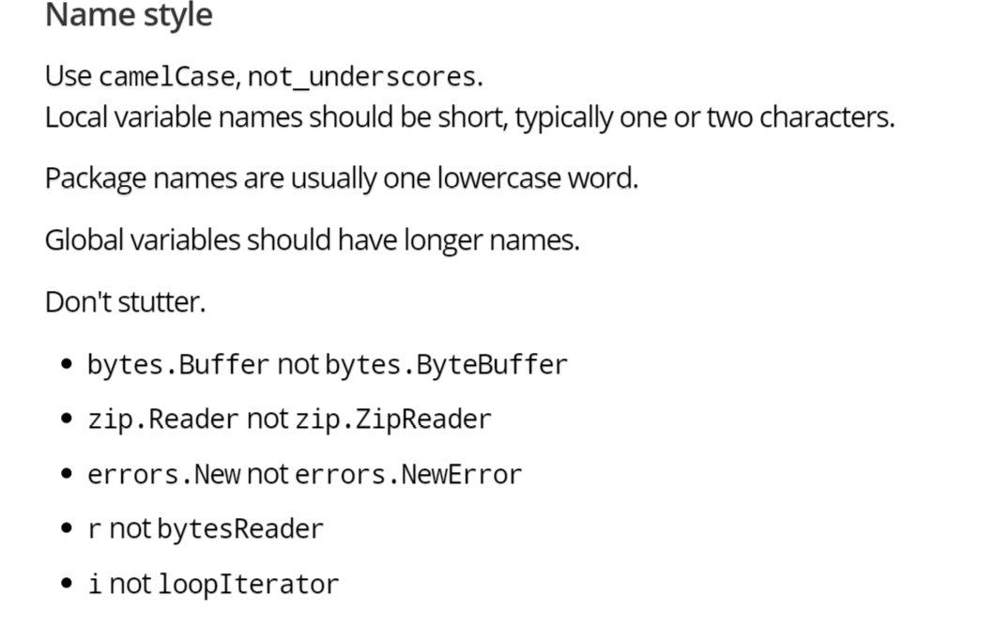

* 1. Comments: Used before an exported type.
  2. Comments should begin with the noun they are describing.

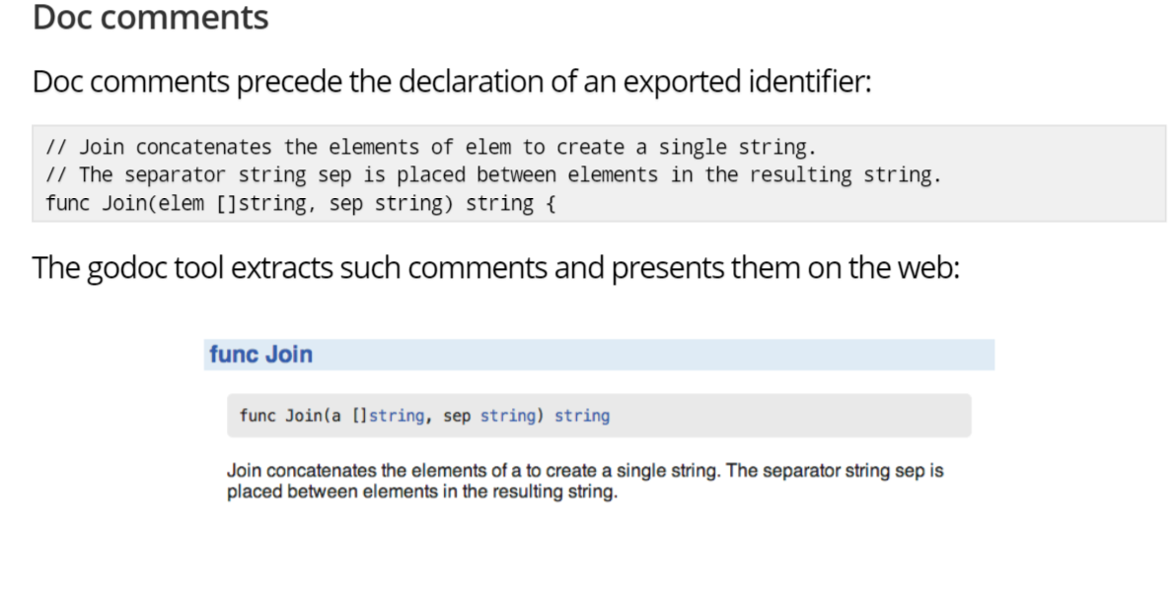

* 1. **Variables**:
  2. There are two main ways to declare variable:
  3. **Shorthand notation** that can only be used inside a function.

x := 5

* 1. Here we don't need to provide the type.
  2. **Inside a function, the := short assignment statement can be used in place of a var declaration with implicit type.**
  3. **At the file level everything excluding comments has to start with a keyword, e.g. package, import, const, type, var, func. So we can't use := to declare a variable outside a function or block scope.**
  4. **This short hand is only used if we are declaring a variable for the first time. If a reassigning a variable then we have to use =**

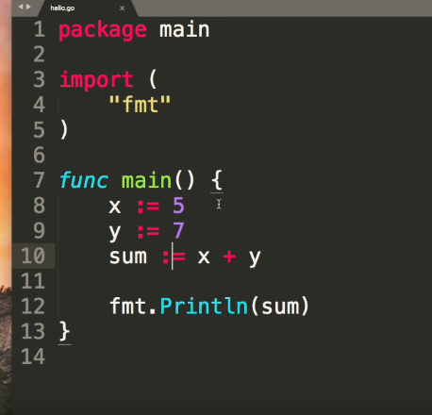

**Important: Redeclaration**:

* 1. **Unlike regular variable declarations, a short variable declaration may redeclare variables provided they were originally declared earlier in the same block with the same type, and at least one of the non-blank variables is new.**
  2. As a consequence, redeclaration can only appear in a multi-variable short declaration. Redeclaration does not introduce a new variable; it just assigns a new value to the original.

a, b := 1, 2

c, b := 3, 4

* 1. Suppose you want to do proper error handling, you can reuse an err variable because most likely you only need it to check if there were any errors during the last function call:

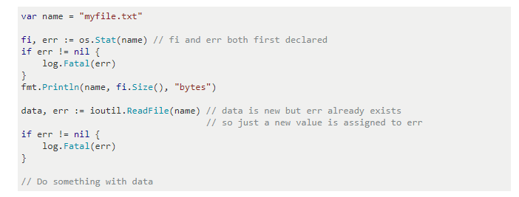

* 1. Var

var x int : creating a variable x of type integer.

If values are not provided to a variable then it would take the 0 value for that variable

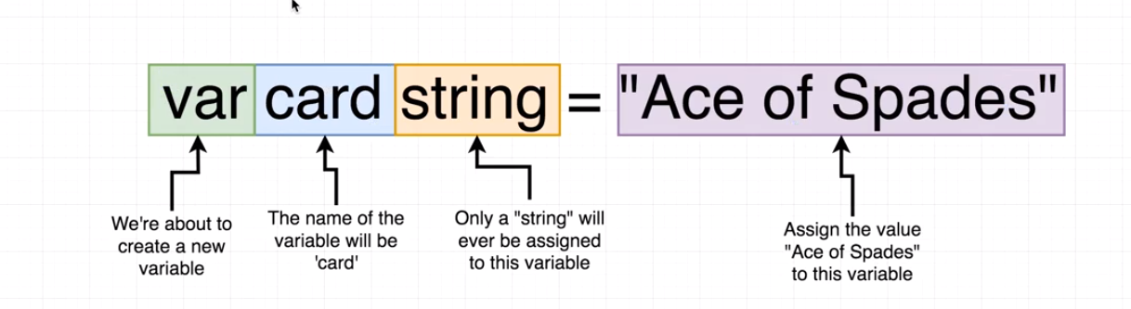

0 value for:

Int -> 0

String -> empty string.

**When a variable is created by not initialized, then it will get zero value.**

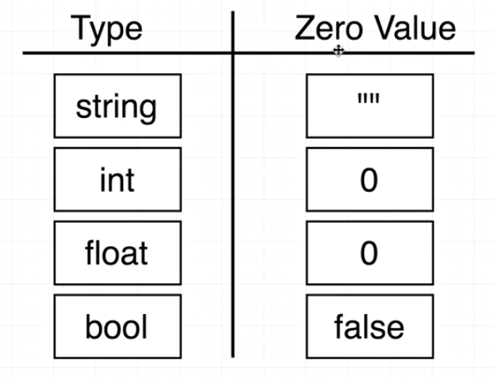

-----------------------------------------------------------------------------------

Print function:

* 1. Fmt.Println
  2. Fmt.Printf

* 1. We can't have more than one function with same name in a file.

----------------------------------------------------------------------------------

**Strings**:

* 1. In golang strings are placed between double quotes and not between single quotes.
  2. Strings in go are UTF-8 encoded by default. (?? What does it mean??)

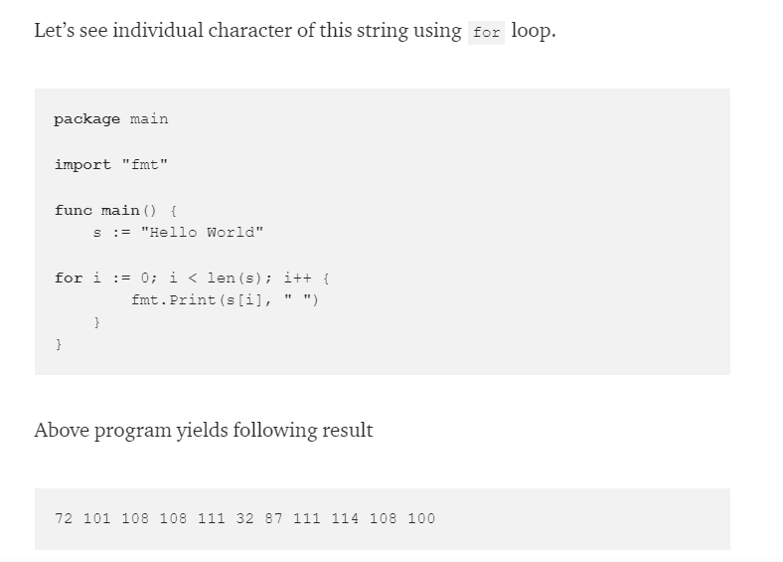

* 1. **In go, String is a read only slice of bytes.**

**package** main

**import** "fmt"

**func main**() {

s := "Hello World"

fmt.Println("len(s)", len(s))

**for** i := 0; i < len(s); i++ {

fmt.Printf("%c ", s[i])

}

fmt.Println("")

**for** i := 0; i < len(s); i++ {

fmt.Printf("%v ", s[i])

}

fmt.Println("")

**for** i := 0; i < len(s); i++ {

fmt.Printf("%x ", s[i])

}

fmt.Println("")

**for** i := 0; i < len(s); i++ {

fmt.Printf("%T ", s[i])

}

}

Output of above code will be :

len(s) 11

H e l l o W o r l d

72 101 108 108 111 32 87 111 114 108 100

48 65 6c 6c 6f 20 57 6f 72 6c 64

uint8 uint8 uint8 uint8 uint8 uint8 uint8 uint8 uint8 uint8 uint8

**each letter shows decimal number which holds 8 bits or 1 byte of memory in type uint8.**

Note:

* 1. UTF8 character can take from 1 byte to 4 bytes, so all characters in go are represented in int32( 4 bytes)
  2. A **code unit** is the number of bites an encoding uses.
  3. So UTF 8 uses 8 bit and UTF 16 uses 16 bits of code unit.
  4. A **code point** is any numerical value that defines a character and is represented by one or more code units depending on the encoding.

Runes:

Type conversion:

* 1. Convert one type of value into another.

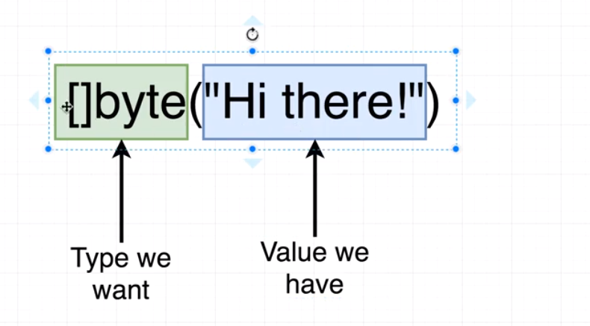

---------------------------------------------------------------------------------------

* 1. **Scope**:
  + Where a variable can be accessed.
  + We want to keep our scope tight. That is use it close to where we are going to use them.

**Types**:

* + Universe
  + Package - Declared outside any function or block. Can be accessed from any file within the package.
  + File
  + Block (braces) - variable defined inside a block can't be used outside it. Also, the order of variable declaration matters. If we used a variable before declaring it inside the method, then it will show error. But if the variable is declared outside the method, then we can use it, even if the variable is declared after that method in which its used.

* + **Within a package, identifiers can be accessed without any restriction.**
  + **If we want to use an identifier outside a package, then its name should start with capital letters.**
  + **Or we can make it start with small letter and use it in a method (starting with capital letter) and use that method.**

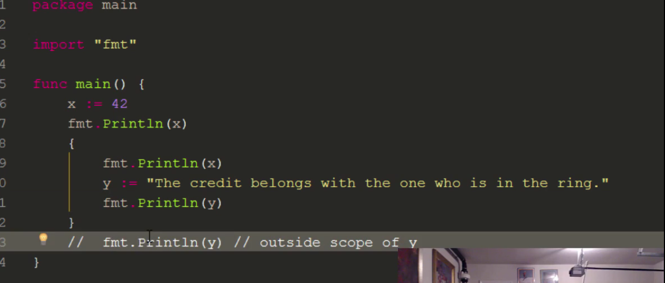

--------------------------------------------------------

**Blank Identifier:**

* + If we create a variable in golang, then we have to use it. We can't declare and not use a variable. Not allowed in golang.
  + To counter this, we can use '_' as a variable name and never use it. This is blank identifier.

-----------------------------------------------------

Constant:

* + A simple unchanging value.

const a string = 'some string'.

For example, following will fail:

const a string = "some string"

a = "some other string"

* + We also declare multiple constants at a time:

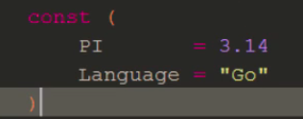

* + No need to capital letter identifier when creating constants in golang.

---------------------------------------------------------------------

**Conditional Statements** :

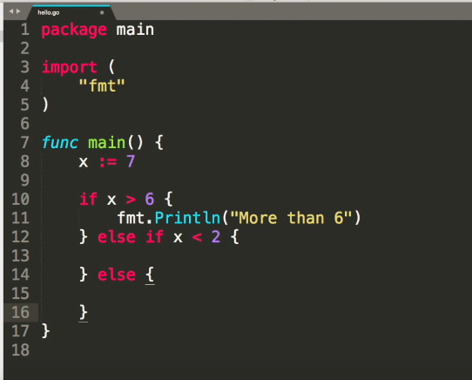

-------------------------------------------------------------------------------------------------------------

**Data Structures:**

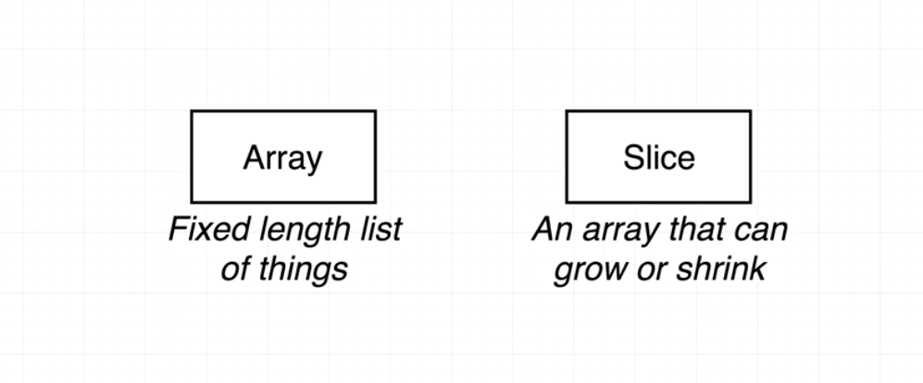

* + **Arrays**:
  + Data structure with fixed length
  + var a[<size>] int
  + **If we provide size in the brackets, then its an array. Else it's a slice.**
  + len(<array>): will give the length of an array.
  + We don't use array in go. Its an underlying data structures that other data structures, like slice, map, use
  + Declaring an array of a type without any values will take the zero values of that type.

Ways to create an array:

var a = [5]int{1, 2, 3, 4, 5}

fmt.Println(a)

a := [5]int{1, 2, 3, 4, 5}

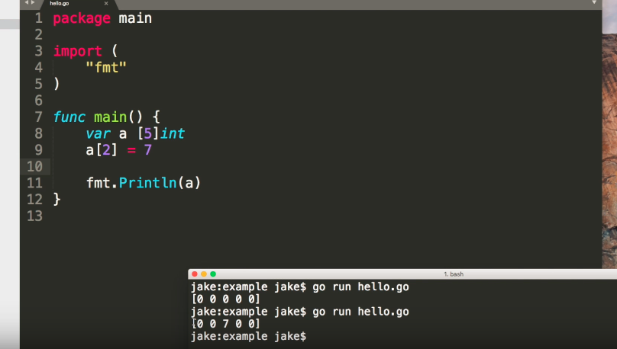

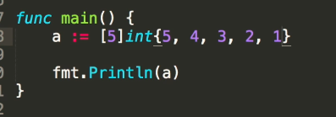

--------------------------------------------------

* + **Slices**:
  + Arrays with dynamic number of elements.
  + Slice data should be of the same type.

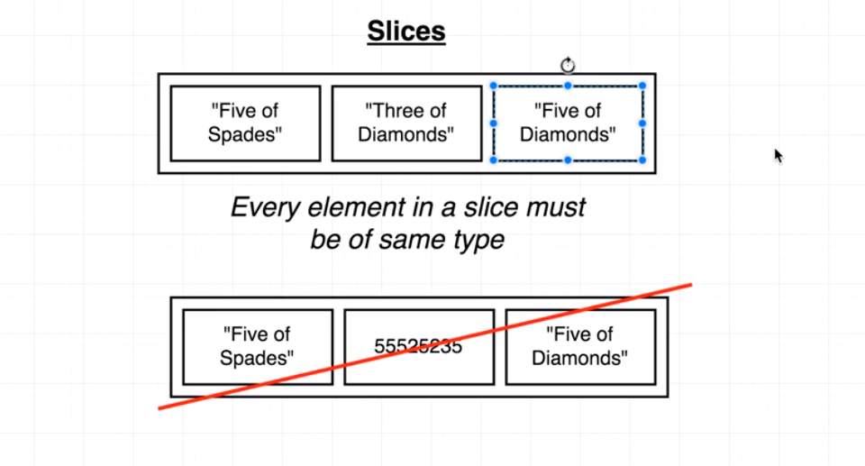

* + Creating slices is similar to creating array but we don't provide the size in brackets.
  + Different ways of making a slice:
  + Var
  + var mySlice []string
  + Shorthand

**mySlice := []string{}**

* 1. Make : this is the preferable way to create a slice.
  + Myslice := make(a[], 50, 100) // here 50 is the size of the slice and 100 is the capacity of the underlying array.

??? Advantage of using make())

* + Slice (maps and channels) are reference types. That is, they are referencing some underlined data structure.
  + Slice has a header having three types of data : 1) pointer to the underlying array 2) Length of the Slice 3) Capacity of the underlying array.
  + When creating slices with var or shorthand the address is not pointing to anything.
  + Hence we can't add the new elements to these slice using assignment operator. We need to use 'append' method in this case.

* + 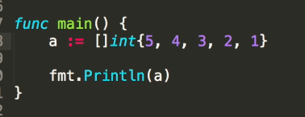
  + With slices, we can use many built in functions as well.
  + 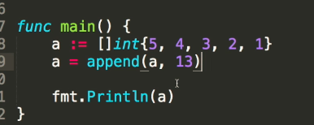
  + Appends returns a new slice we need to assign it to new or existing variable in order to use it.
  + **Syntax for append: newSlice = append(existingSlice, <item>)**
  + **When we try to add elements to slice more than the capacity of the underlying array, go will throw away the old array, create a new array with double the capacity, add elements of the previously thrown array to it. This only works with the append method.**
  + **When we specify only one element in the make function to make a slice, then that number becomes both the length and the capacity.**
  + We can also append one slice to another slice
  + 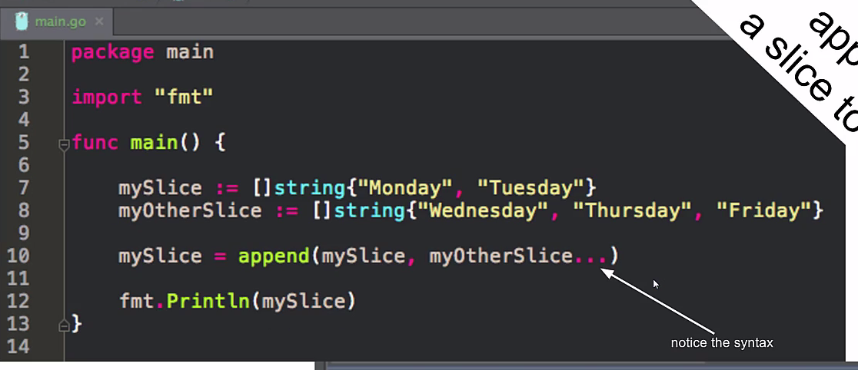

* + Multi dimensional Slice: Slices within a slice.

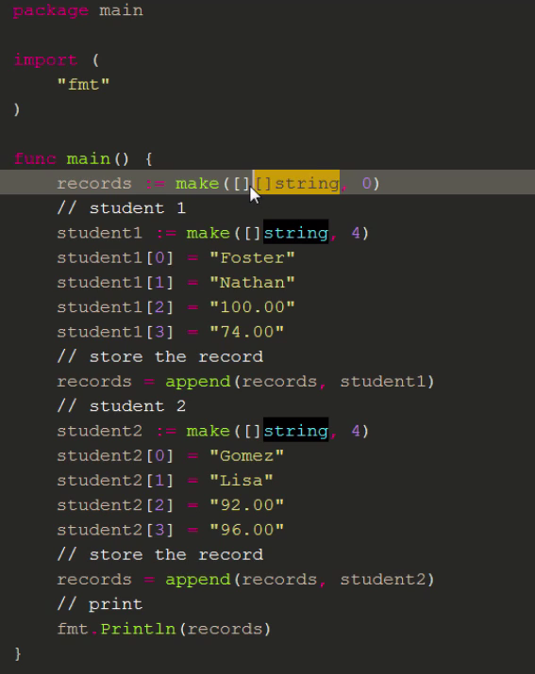

* + Advantages of using append method:

Append method increases the size of the underlying array when adding element more than the original size.

* + 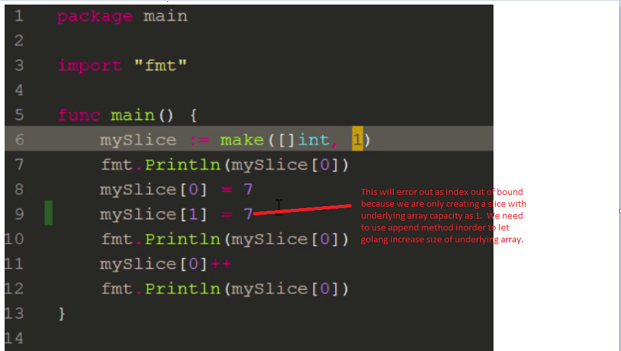

* + Below method will work as we are appending which will increase the array capacity
  + 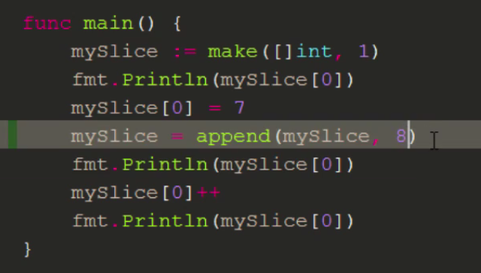

Incrementing a slice item:

* + Three ways to do this:
  + Myslice[0]++
  + Myslice[0]+=1
  + MySlice[0] = Myslice[0] + 1

------------------------------------------------------------------------------------------------------------------------

* + **Maps:**
  + To hold key value pairs. Like dictionaries in python.
  + Both key and values are statically typed. And all the keys together and all the values together should be of the same type:

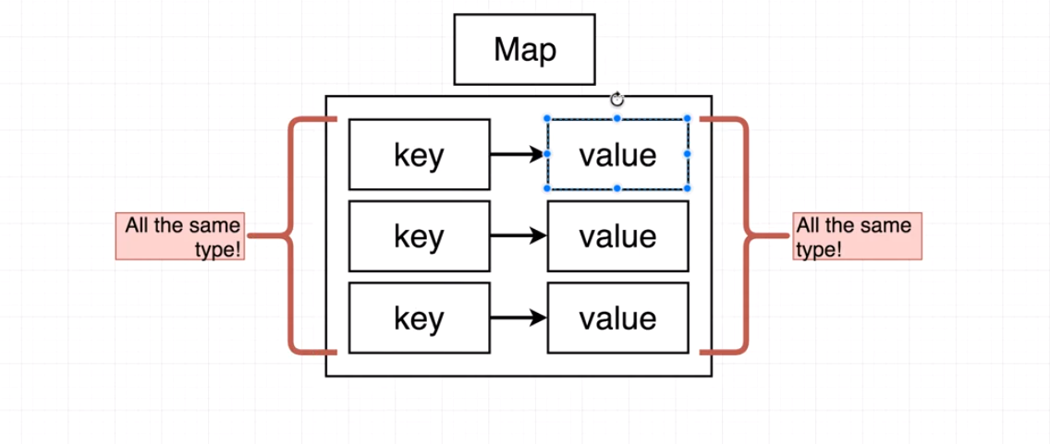

* + Creating and accessing a map:
  + Ways to create a map
  + Simple way:

Color := map[string]string{

"red": "#FF000",

"blue": "#55500",

}

* + var color map[string]string
  + Zero value of a map is an empty map.
  + We use this approach we can want to add data to later and not when its created.

* + Built in function to create map

Colors := make(map[string]string)

**We can add values to map using square brackets syntax:**

**colors["white"] = "FF000"**

**We can't use dot operator to access map data. We can only use square braces.**

* + 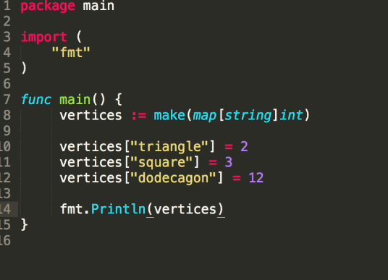
  + We can use delete function to delete from the map:
  + 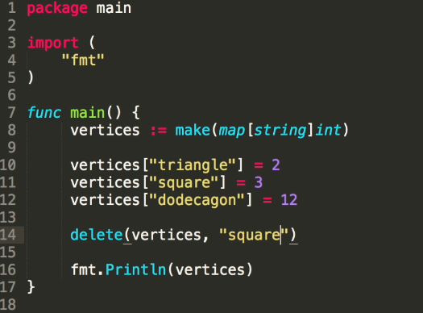

* + Iterating over a map:

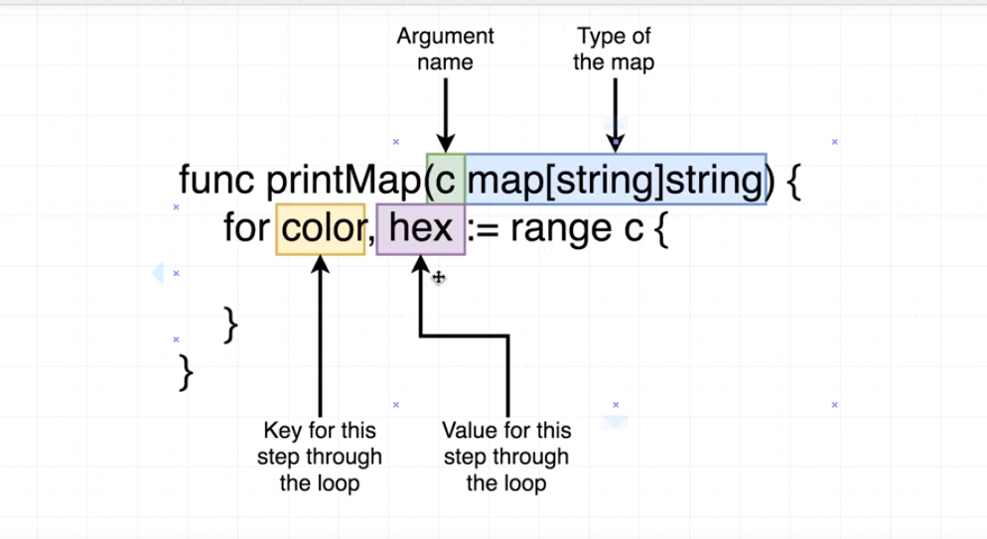

When to use maps and structs:

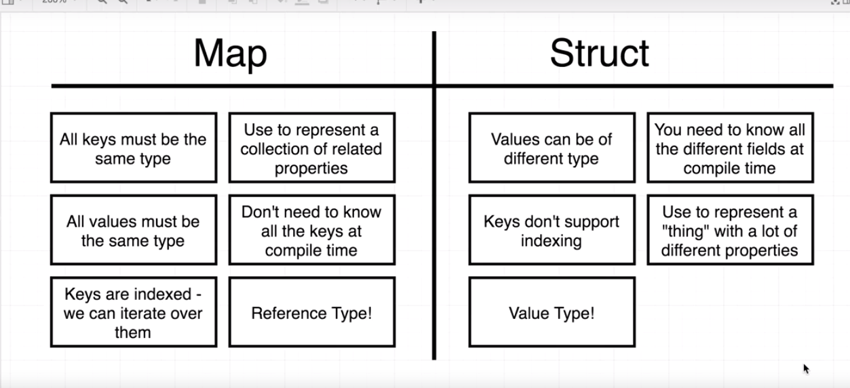

* + We want to use a map when we are dealing closely related values. For example, map of colors with hex code values.

---------------------------------------------------------------------------------------------------------------------------

* + **Structs**:
  + It’s a data structure in go.
  + Collection of different properties related together.
  + 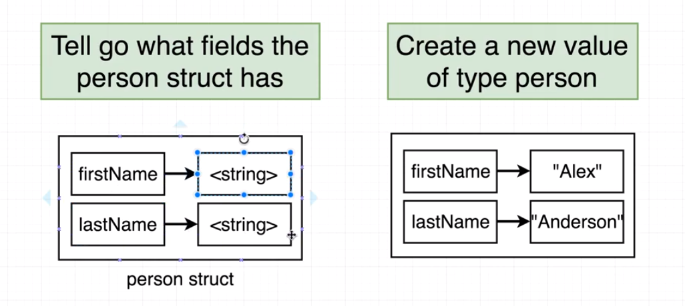
  + Struct can be related to plain objects in Javascript.

* + We can embed one struct into another like:

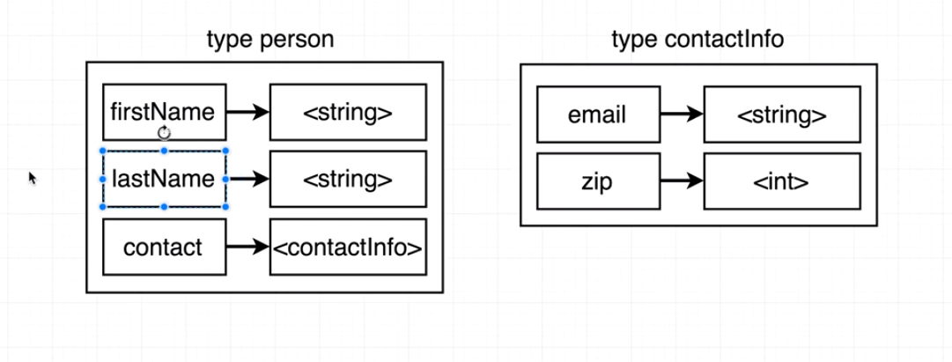

* + Apart from the built-in types, user defined types can also be created in golang.
  + We use the keyword 'type' to do this. For example

type foo int

* + This creates a type foo with underlying type as int. So we can assign int values to foo.

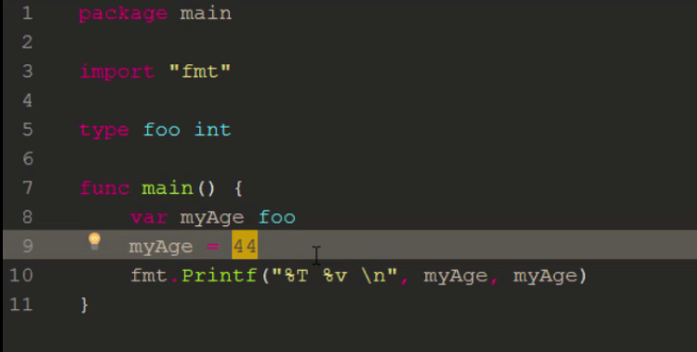

* + Here myAge is of type foo and we can assign it an integer because the underlying type for foo is int.
  + Structs are sequence of named elements called fields, each of which has a name and a type.
  + Field names can be specified implicitly(identifier list) or anonymously.
  + Within a struct, non blank field names must be unique.
  + Field declared with a type but no explicit field name is an anonymous field.
  + This is also known as embedded field or embedding of a type in a struct.
  + Go is not Object Oriented

(1) Encapsulation - We create our own type which has fields (state in oop) and we can add methods to these fields.

Go has exported/unexported (visible/non visible) for private and public access.

state ("fields")

behavior ("methods")

exported / un-exported

(2) Reusability

inheritence ("embedded types")

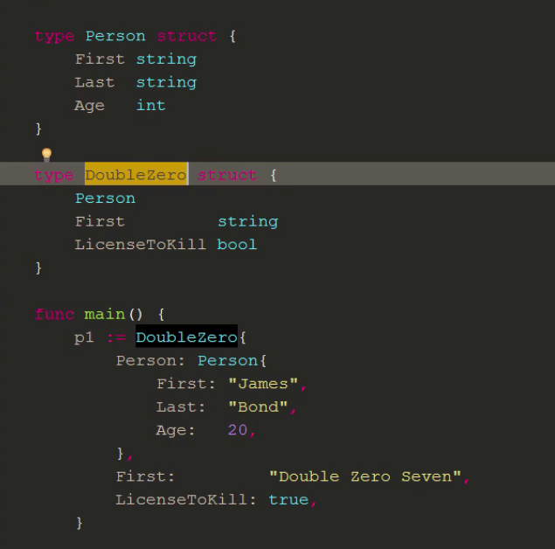

* + A field declared with a type but no explicit field name is an *anonymous field*, also called an *embedded* field or an embedding of the type in the struct.
  + An embedded type must be specified as a type name T or as a pointer to a non-interface type name *T, and T itself may not be a pointer type.
  + **The unqualified type name acts as the field name.**

(3) Polymorphism

Interfaces

(4) Overriding

"promotion"

Tags with Struct:

* + Go does not use OOP like other languages. Here we create a 'type' and then we create 'variables' for that type.

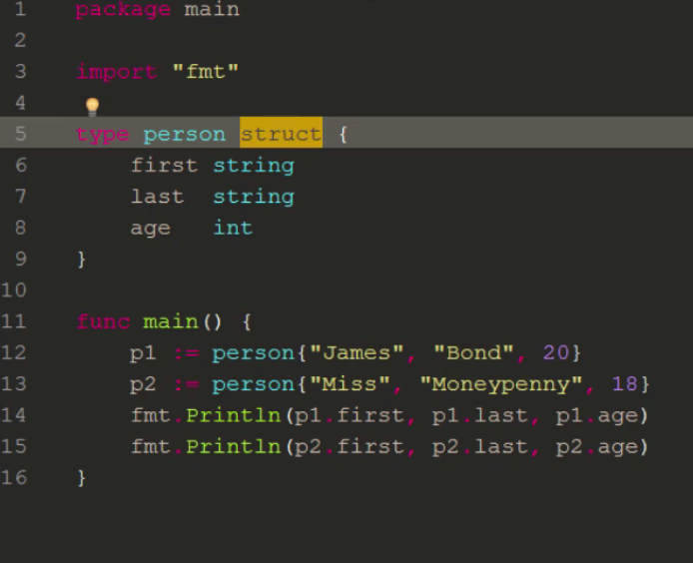

Methods in Structs:

* + Common method pattern : func + receiver + function name + parameters + return type + body
  + The receiver attaches the method to a particular type.
  + The receiver is like 'this' or 'self' in other languages. We don't use 'this' or 'self' in golang.
  + If we are not using receiver variable inside our code, then we can remove the variable in the function receiver and only use the type:

func(type) name(){

}

Json:

* + Marshal : string
  + Encoding: stream

Marshal: Convert Struct data to json.

Unmarshal: Covert json to struct

Marshalling and unmarshalling are used for data within our application.

encoding: Covert a struct data to stream. We use the writer interface to writer the encoded data.

Decoding: covert stream to struct

Encoding and decoding are using coming or going out of application.

---------------------------------------------------------------------------------------------------------------------------

Interface:

* + **What is interface?**
  + Interface is two things:
  + A set of methods
  + A type

* + When interface is a set of methods, any type that’s define those methods (that is, there is a definition for those methods with the second type as a receiver), is set the satisfy/implement that interface
  + There is no implements keyword in go. Whether a type satisfy an interface or not , is determined automatically.
  + **This is a core concept in Go’s type system; instead of designing our abstractions in terms of what kind of data our types can hold, we design our abstractions in terms of what actions our types can execute. ???**

For Example:

type Animal interface {  
 Speak() string  
}

type Dog struct {  
}

func (d Dog) Speak() string {  
 return "Woof!"  
}

type Cat struct {  
}

func (c Cat) Speak() string {  
 return "Meow!"  
}

type Llama struct {  
}

func (l Llama) Speak() string {  
 return "?????"  
}

type JavaProgrammer struct {  
}

func (j JavaProgrammer) Speak() string {  
 return "Design patterns!"  
}

func main() {  
 animals := []Animal{Dog{}, Cat{}, Llama{}, JavaProgrammer{}}  
 for _, animal := range animals {  
 fmt.Println(animal.Speak())  
 }  
}

* + Why we need interface?

We know that:

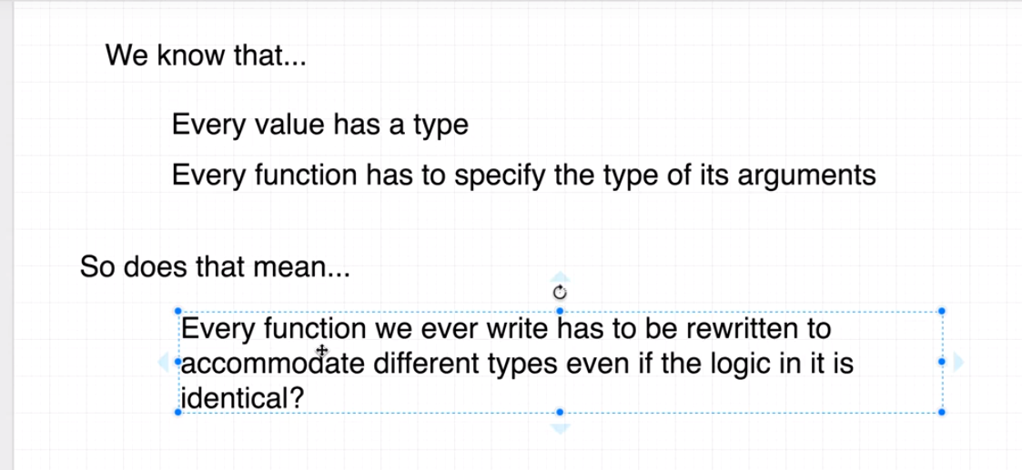

* + Interface helps to reuse code between different parts of our code base.
  + We can reuse a function across different types.
  + Makes go application maintainable and scalable.
  + It helps to achieve polymorphism in golang.

Consider a simple example below:

* + 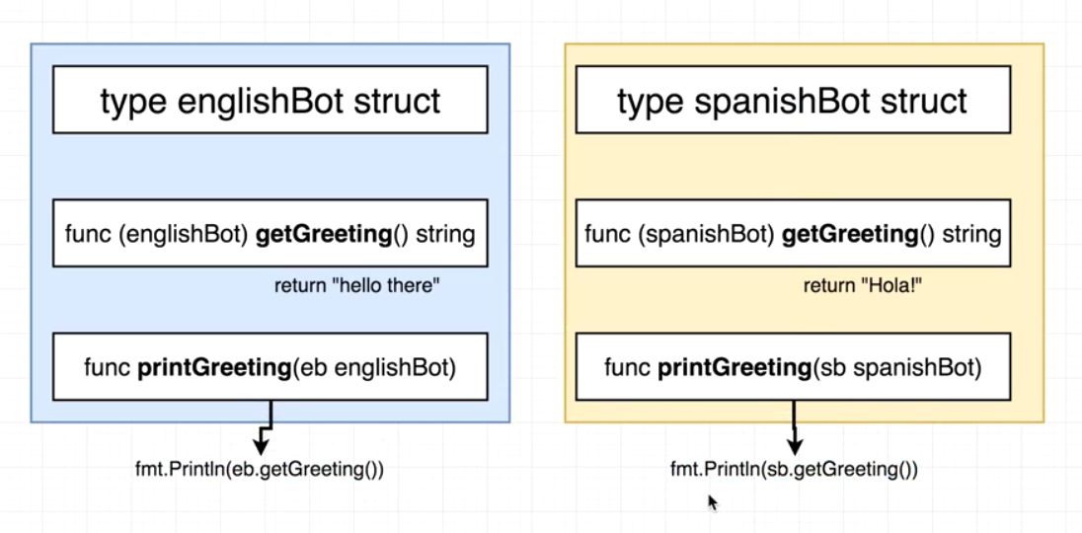
  + getGreeting() method for both englishbot and spanishbot receiver returns different string (that is, they have different logic)
  + Here printGreeting method takes englishbot and spanishbot but they are doing same thing (that is to print)

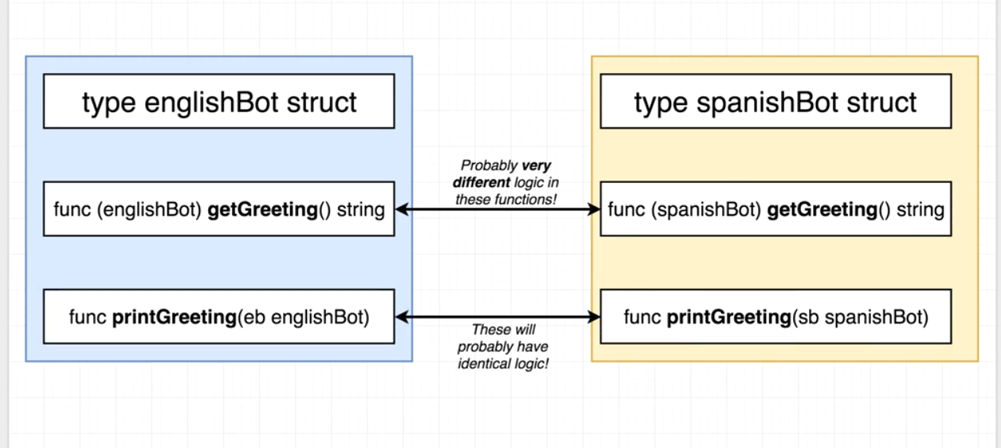

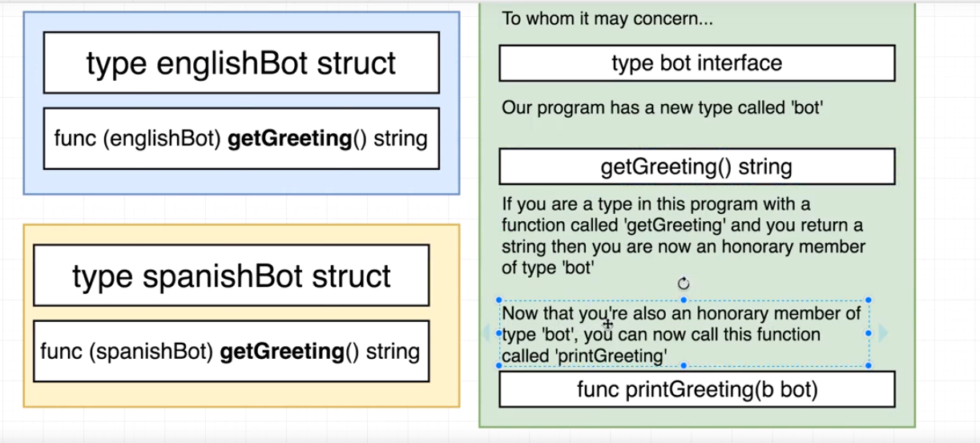

Syntax for interface:

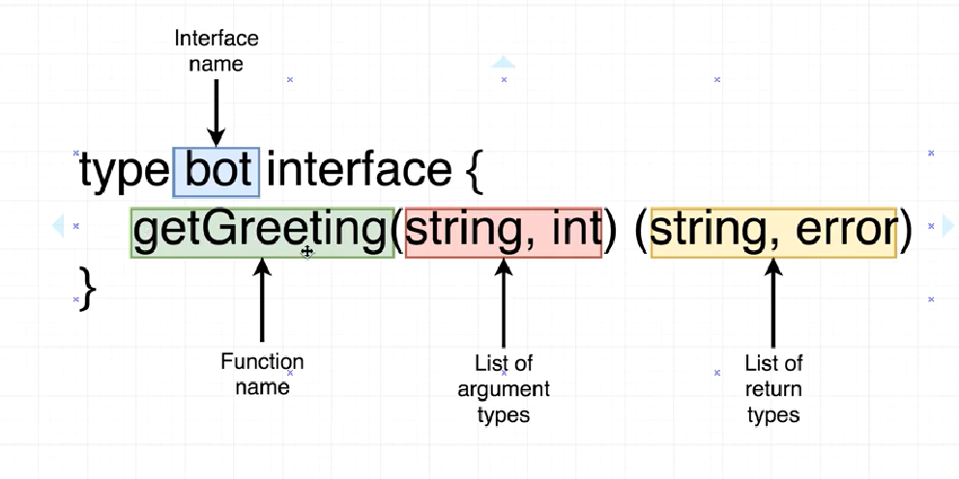

* + So in short, we define an interface with some functions (with specific arguments and returns). All those types that implement these functions (written inside the interface body) can be of that interface type, that is, invoke functions invoked by that interface.

* + Concrete Type: We can directly create a value out of these concrete types.

For example:

type spanishBot struct {}

We can do : --> sb := spanishBot{} like this.

type bot interface{

somemethod()

}

* + We can't do this --> b := bot {}

* + Interface Type: we can't create a value of out the interface types.

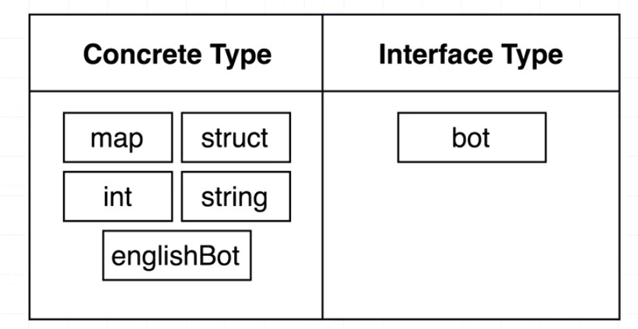

* + Some Notes about Interfaces.

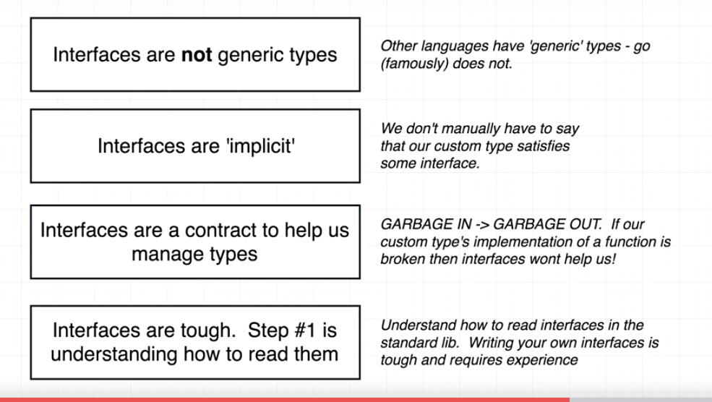

* + Understanding interfaces using the net/http package.

* + Below is Response struct that is returned as a result of http get method:

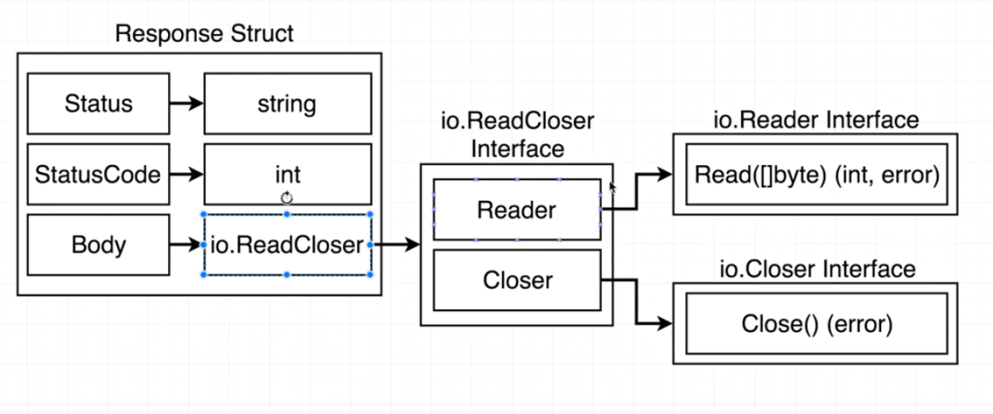

* + Here Body is assigned to an interface.
  + It means that we can assign any value to 'Body' so long it satisfies the io.ReadCloser interface.
  + We can also have interface inside another interface.

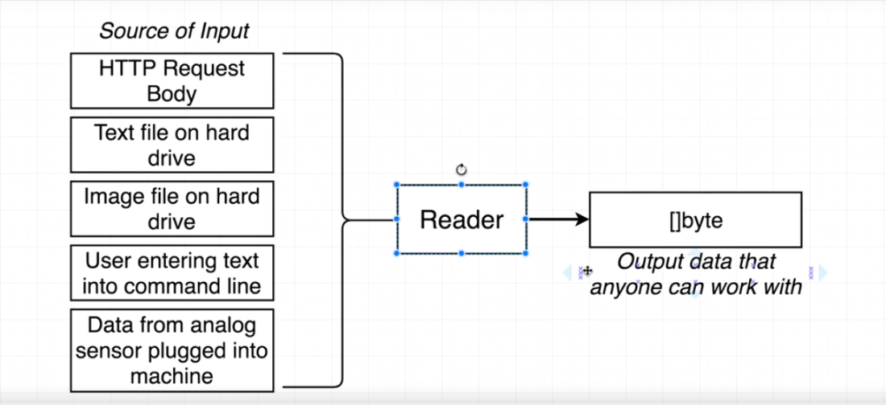

Basics:

* + Interfaces are types in golang (similar to structs)
  + Syntax:

type myInterface interface {

}

* + Interface describe behavior.
  + So we store method definitions inside interfaces.

Once a type implements an interface, any entire world of functionality can be opened up to the values of that type .

Example:

package main

import (

"fmt"

"math"

)

type Shape interface{

area() float64

}

// Square

type square struct{

side float64

}

func (s square) area() float64 {

return s.side * s.side

}

// circle

type circle struct{

radius float64

}

func (c circle) area() float64 {

return math.Pi * c.radius * c.radius

}

func info(z Shape){

fmt.Println(z)

fmt.Println(z.area())

}

func main() {

s := square{10}

c := circle{3}

info(s)

info(c)

}

Power of interface:

* + Polymorphism is the ability to write code that can take on different behavior through the implementation of types.
  + If a thing is implementing/satisfying an interface then it can be passed to a method that takes that interface.
  + Interfaces are types that declare behavior.
  + This behavior is never implemented by the interface type directly, but by the use defined type via methods.
  + **When a user defined type implements a set of methods defined by the interface type, values of the user defined types can be assigned to interface types.**
  + **This assignment stores the value of the user defined type into the interface value**.

Empty Interface:

* + Interface having no methods
  + **Everything implements an empty interface.**

Best **Practices:**

* + **Good to have single method interfaces.**

---------------------------------------------------------------------------------------------------------------------------

Loops:

* + We can use only for loop in golang.
  + 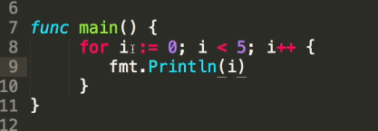
  + We can use the for loop itself to create a while loop:

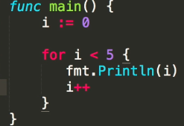

* + We can loop across the index and the value of an array using the range :

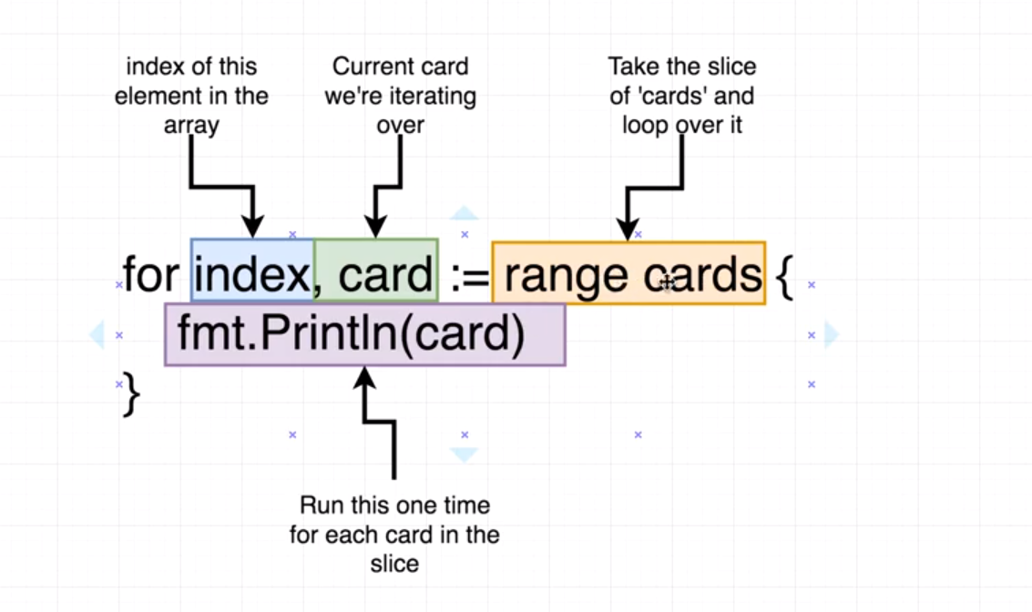

dsl

* + 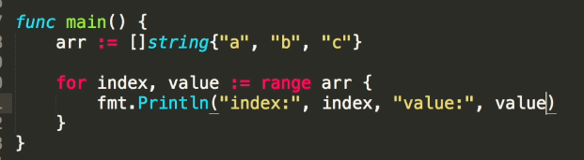
  + We can loop across the key and value of a map using the range function:
  + 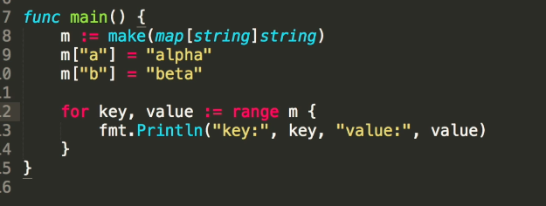

-----------------------------------------------------------------------------------------------------

Functions:

* + We can create functions in golang using the following syntax:

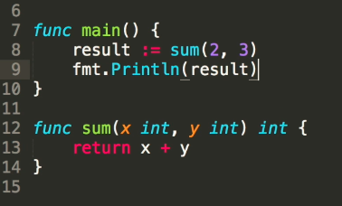

* + In go, functions can return multiple values.

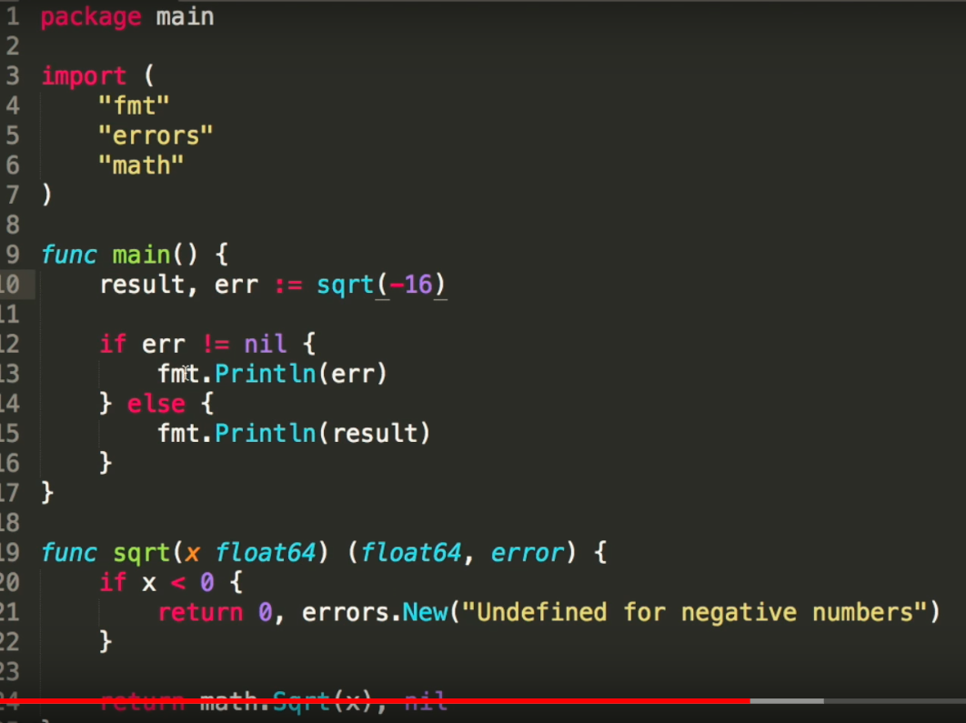

* + Here the function sqrt is returning two values - float64 and error (from the errors package).
  + Go does not have exceptions like other languages, so we can use errors package to handle any error.

--------------------------------------------------------

Struct:

* + A collection of fields to group things together so that we can create a more logical type.
  + Syntax:

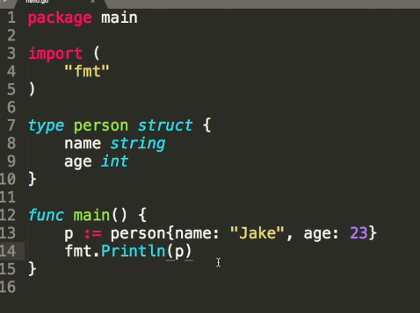

* + We can use dot notation to get the specific item from the struct:
  + 

-------------------------------------------------------------------

**Pointers:**

* + In below example:
  + Golang is pass by value. So every time we pass a something to a function **either as a receiver or as a argument**, a copy of that value will be created and the called function will work on the copy and not the actual value.
  + Pass by value happens for integer, float, string and struct

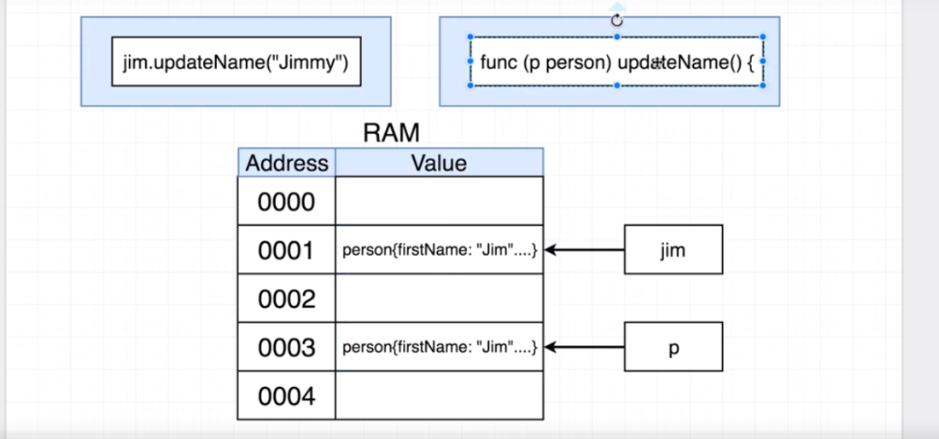

* + 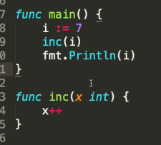
  + I is passed by value into the inc function
  + Which means golang will take value of 'I' and store it into a new variable 'x' inside the RAM.
  + so x++ won't effect 'I'.
  + Instead we can pass 'I' by reference (using pointers).
  + In this case, an increase in x inside the inc function will reflect in 'I'
  + Sending a pointer to a value, will make the inc function to look at the value at that memory address.

Important:

* + **We can send a pointer using & with the value.**
  + **We can accept a pointer by prefixing the type with an asterics \***
  + **Deference the pointer in the method so that its affecting the actual value and not the address.**

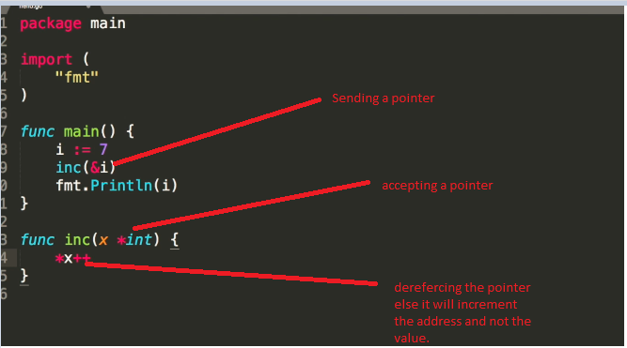

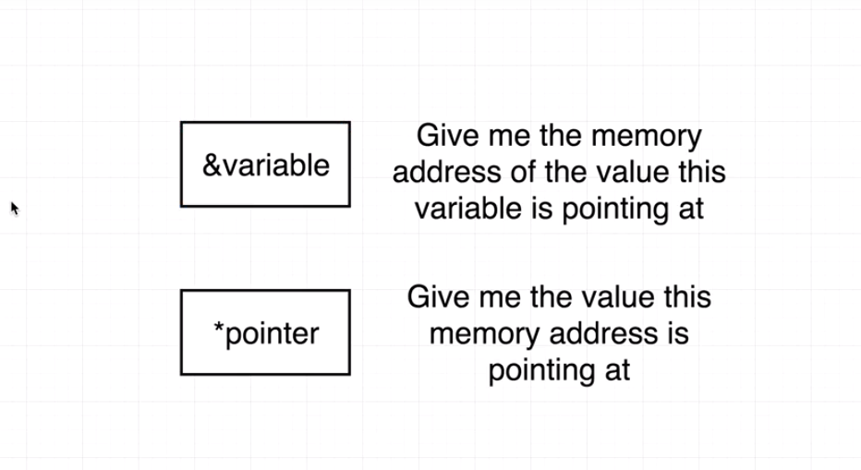

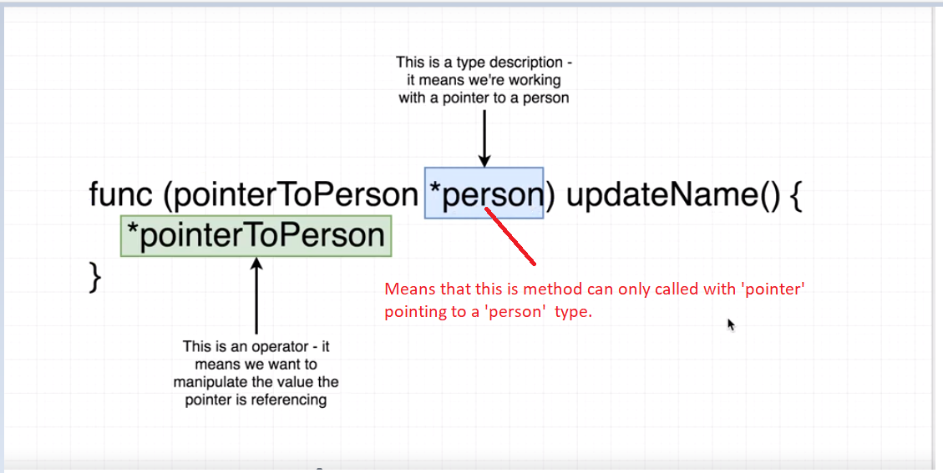

Sample

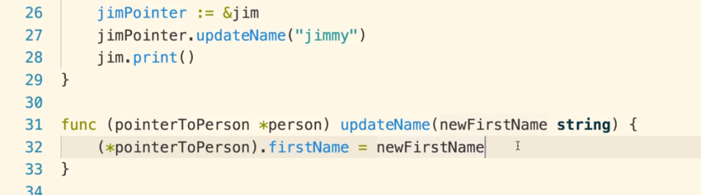

- So basic pointer rule:

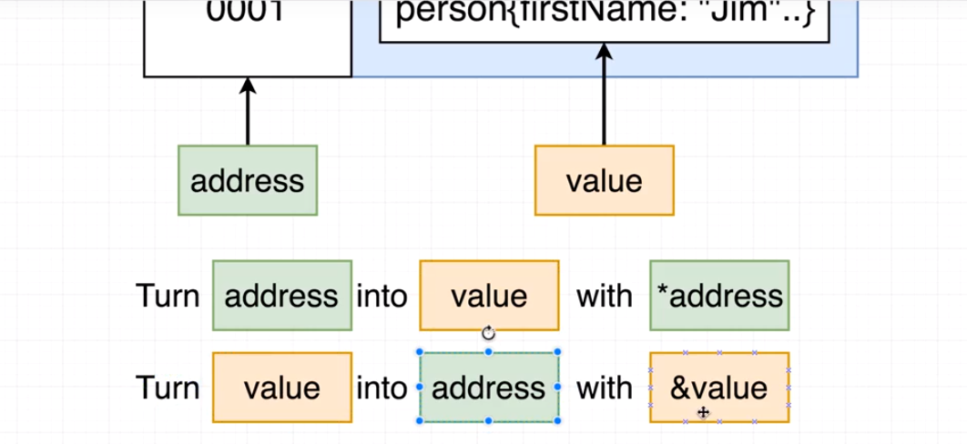

**and * has a different meaning when used before a 'type' and when used before a memory address or pointer.**

**As a shortcut, we can directly call function with a type of struct, where function receiver is a pointer to that struct. Both these approaches below will work:**

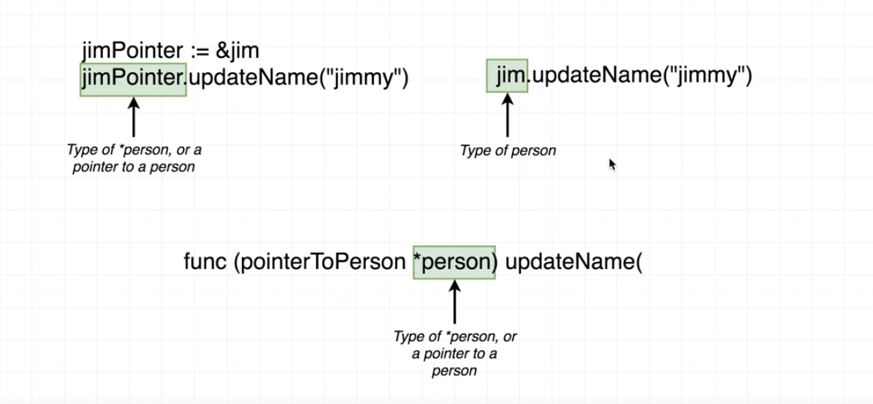

**Very important:**

**So in short, *type in the receiver part of the function can take both the actual type and the pointer to that type**.

* + Gotchas with pointer.
  + Pointers concept work differently for slices.

- if we pass a slice to a function argument, then any change in the called function would reflect in the original slice without even using pointers.

* + 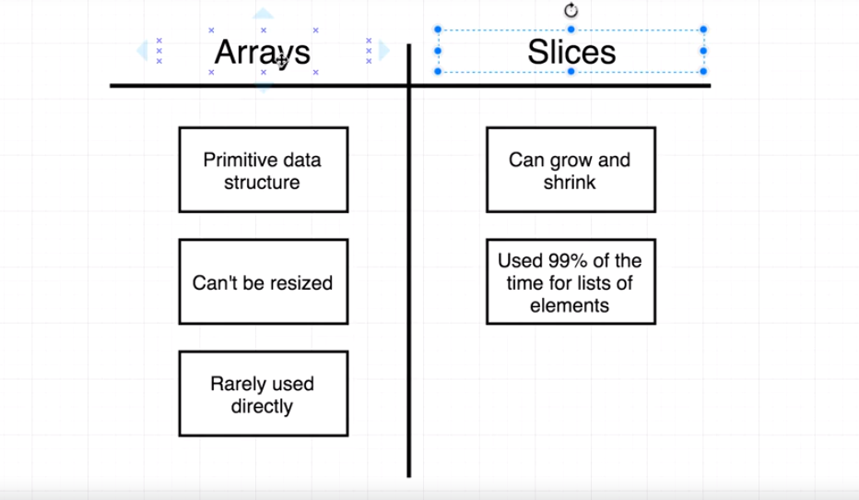

* + When we create a slice, the go internally creates two data structures for us.

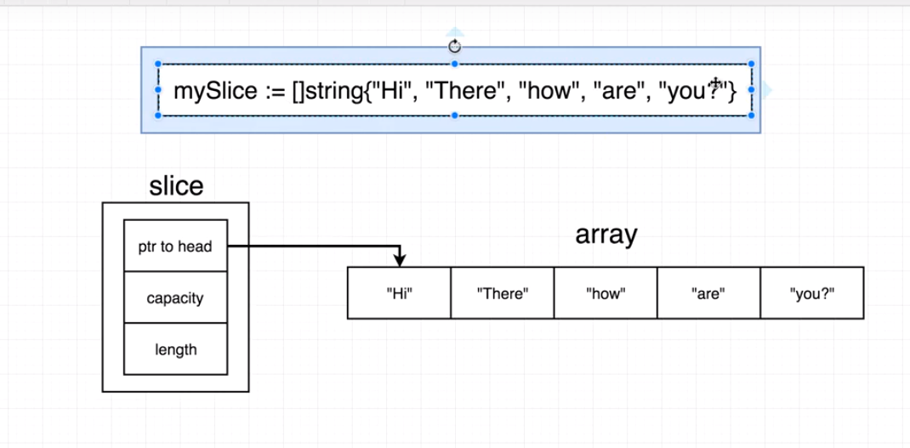

* + When we pass this slice to a function its still pass by value and new copy of the 'slice' is created at a different location.
  + But that new copy of slice is still pointing to the same underlying array.
  + 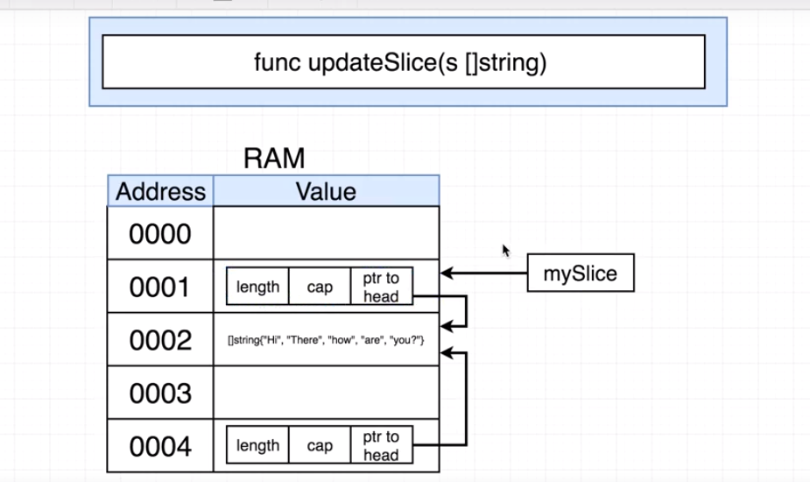
  + So any change in the slice in the called function will affect the underlying array only.
  + That's why we can see the change in the original slice.

* + So we don't need to use pointers for reference types. But sometimes we may want to use it for cases like changing the length of the slice in a function.

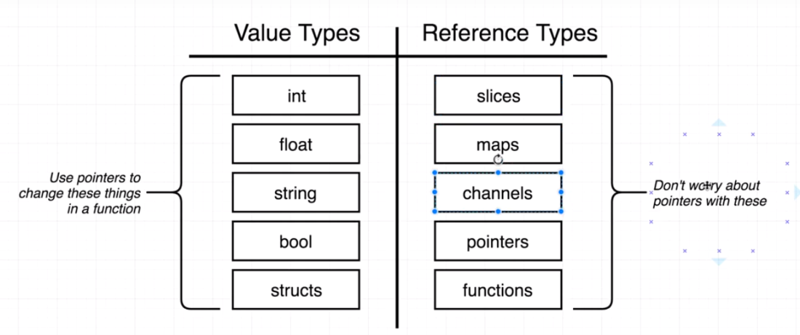

* + **When to use a pointer receiver vs non Pointer receiver:**
  + Understand the type being passed as receiver. Slices, maps, channels, pointers and functions behave like paas by reference. So even if we don't pass as pointers, any change in the called function would reflect in the original data.
  + "First, and most important, does the method need to modify the receiver? If it does, the receiver must be a pointer."
  + "Second is the consideration of efficiency. If the receiver is large, a big struct for instance, it will be much cheaper to use a pointer receiver."
  + "Next is consistency. If some of the methods of the type must have pointer receivers, the rest should too, so the method set is consistent regardless of how the type is used"

-------------------------------------------------------------------------------------------------------------------------

OO in Golang:

* + Go is not Object Oriented Programing language.
  + OO approach for dec of cards program:

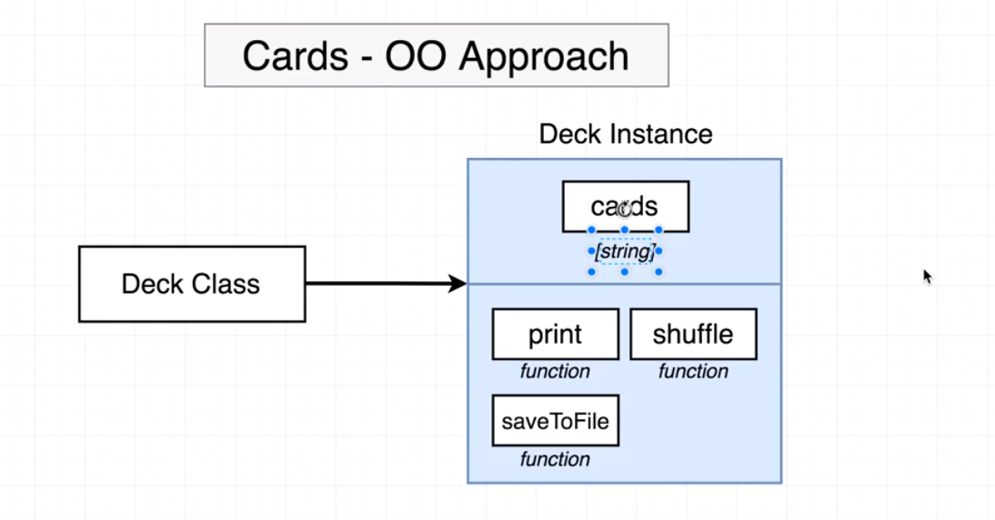

* + Go's approach:

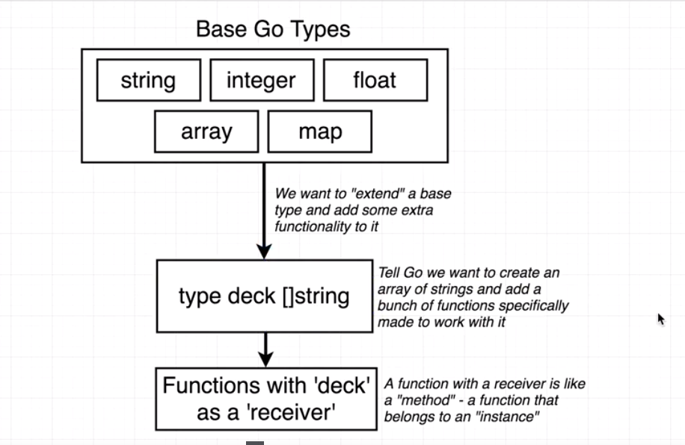

* + 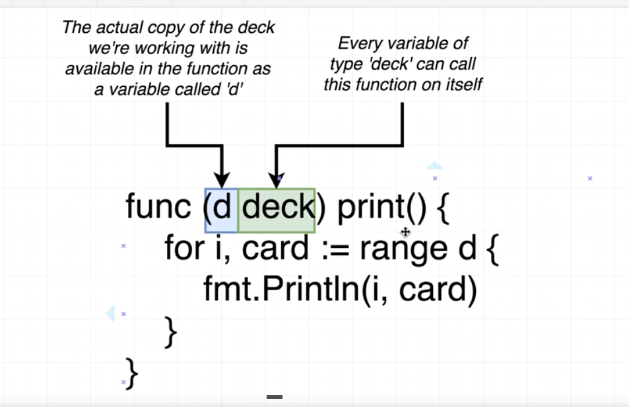
  + Receiver Function:

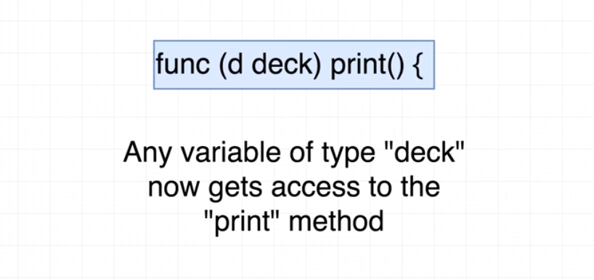

Errors in golang:

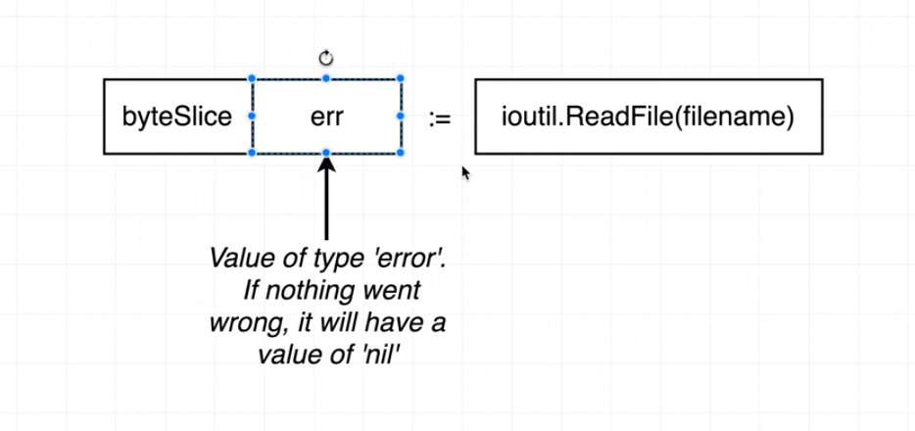

Tests in Go:

* + 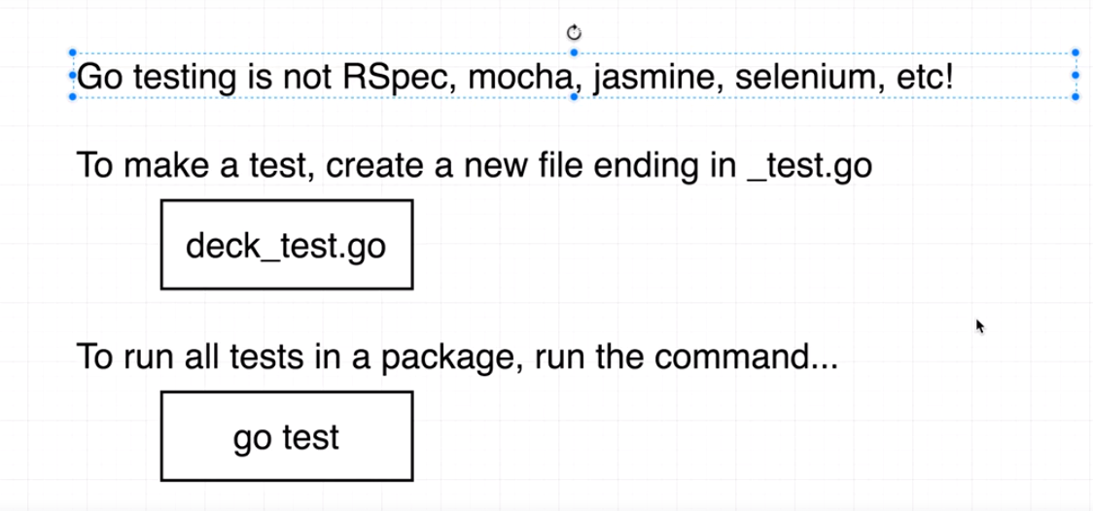
  + Test function name should start with 'Test'

-----------------------------------------------------------------------------------------------------------------------

**Go concurrency:**

* + Making progress on more than one task simultaneously is known as concurrency.

- Normally when we invoke a function our program will execute all the statements in a function and then return to the next line following the invocation.

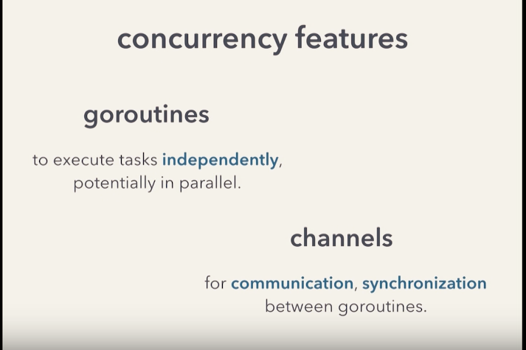

**Goroutine**:

* + A goroutine is a function that is capable of running concurrently with other functions.

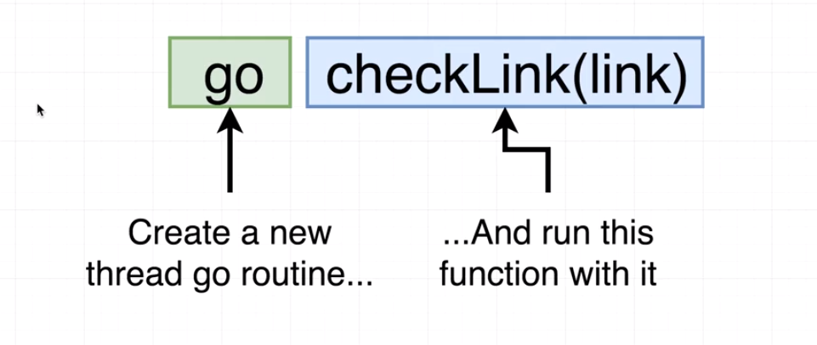

* + To create a goroutine we use the keyword go followed by a function invocation:

- With a goroutine we return immediately to the next line and don't wait for the function to complete.

* + Concurrency is not parallelism
  + **Parallelism means to run two things at the same time. This happens in multi core processors where each core is running different functions simultaneously.**
  + **Concurrency is about breaking up the program into independently executing tasks that could potentially run at the same time and still getting the right result at the end**
  + Concurrency means **dealing with** lots of things at the same time. These things are related to each other.
  + Parallelism is **doing a lot** of things at the same time. This is simultaneous execution of lots things (which can be related or unrelated).

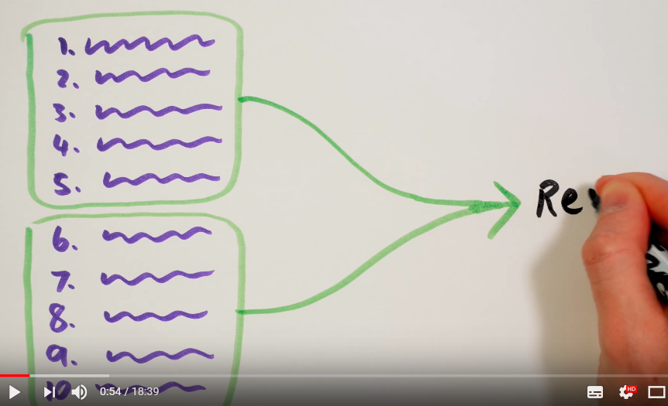

* + A concurrent program is one that can be parallelized.

* + For example:
  + 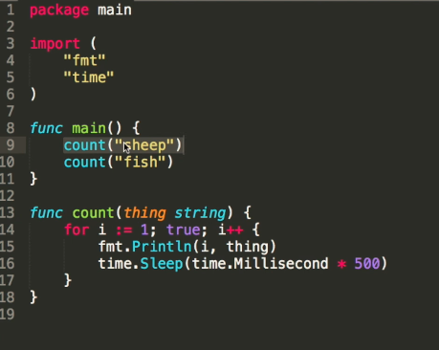
  + This function count takes a string and print it infinitely.
  + This is sequential program as it will only print sheep and wait for it to complete before starting with printing 'fish'.

* + If we use the word 'go' before it, then it won't wait for that function to complete before moving onto the next line.
  + It will run the function in the background and continue to the next line immediately.
  + This creates a goroutine (function running in the background)that will run concurrently.

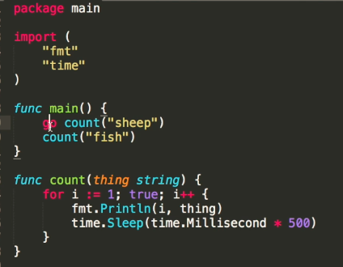

* + **Main function is golang is also a goroutine.**
  + **The program ends when the main gorountine function ends even if there are other go routines still running.**
  + The below code will exit without printing anything as we made both methods a go routine, and both will wait for for 500 ms and before that the main go routine will finish:

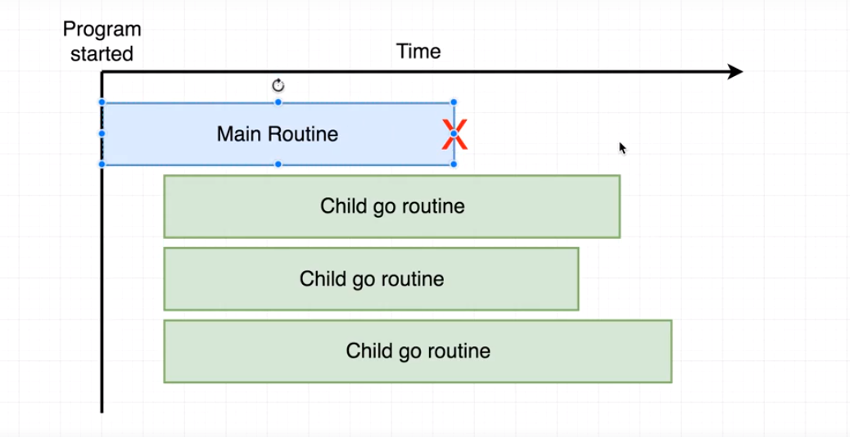

* + Unlike example above, now the second count method is not part of the main go routine, so we have three different go routines, count go routines will print infinitely but main go routine will finish as soon as there are no code to execute.

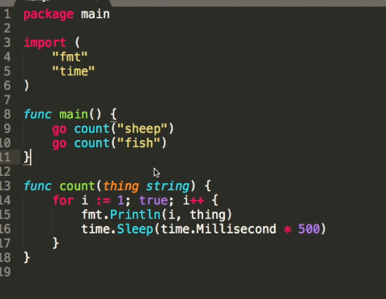

* + To solve this problem we can use **fmt.scanln()** at the end of the main function, as it will wait for some user input before ending main go routine.

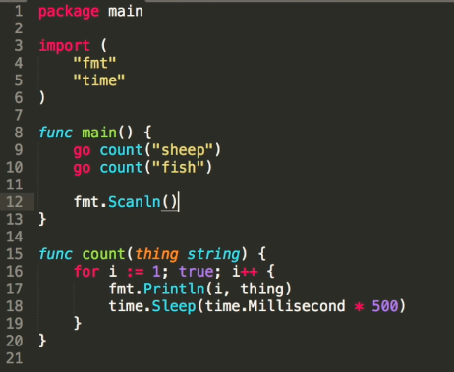

* + Scanln() is not an effective way as it involves some manual interaction.

* + Another way to solve this issue is to use a waitgroup by:
  + Importing the 'sync' package.
  + Waitgroup is just a counter. We can increment it just before calling a goroutine.
  + Decrement the counter when the goroutine finishes.
  + Main go routine will only exit when it sees that there are no pending goroutines that are running.
  + We need to call wait at the end of the main function to use it.

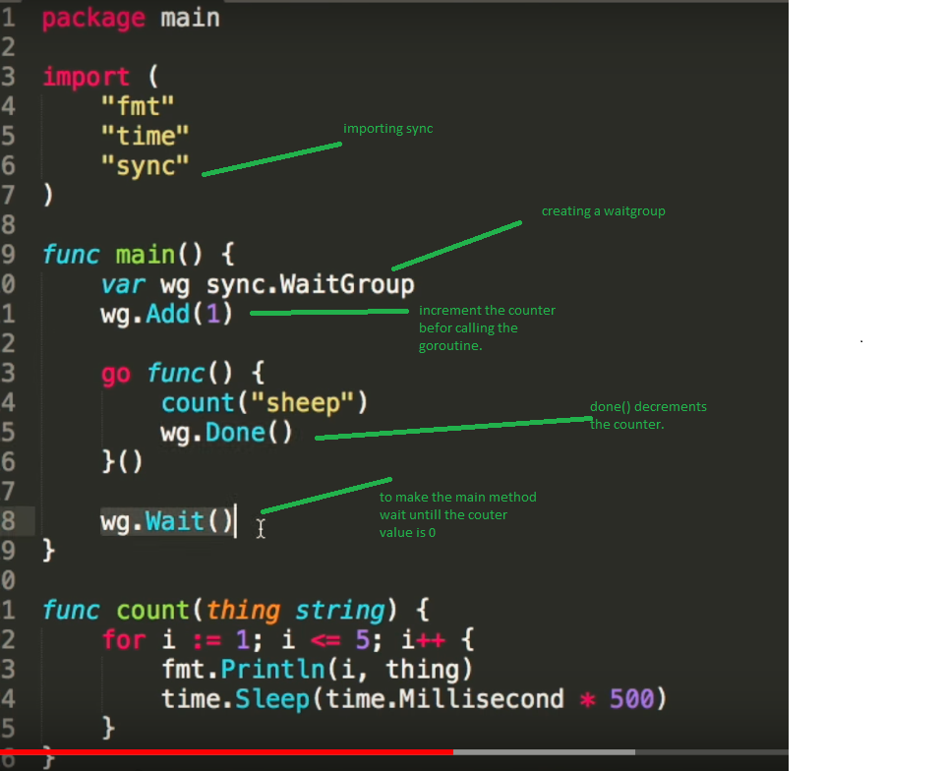

* + Go routines are efficient and we can make thousands of go routines but adding more go routines won't make our cpu fast as our :

Go Theory:

* + By default go attempts to use only one CPU core:

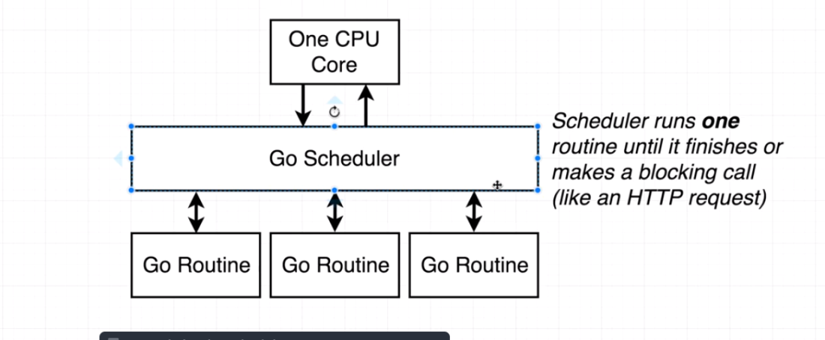

* + Parallelism only happens when we have multiple CPU cores:
  + 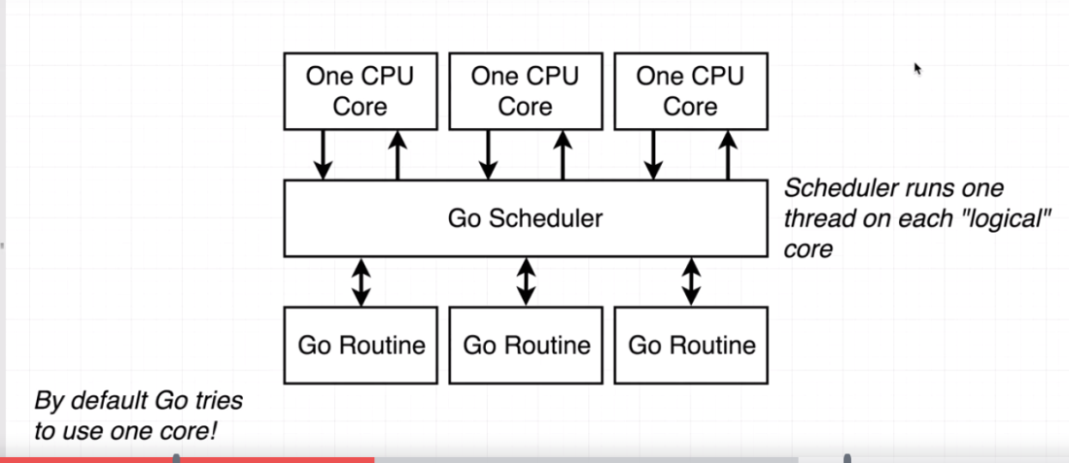

* + Concurrency is not parallelism:

in Concurrency we run multiple things kind of at the same time but not actually at the same time. Other program only runs when currently running program is blocked for some reasons. This usually takes place is a single core processor.

- in parallelism, programs actually run at the same time, but in different CPU cores.

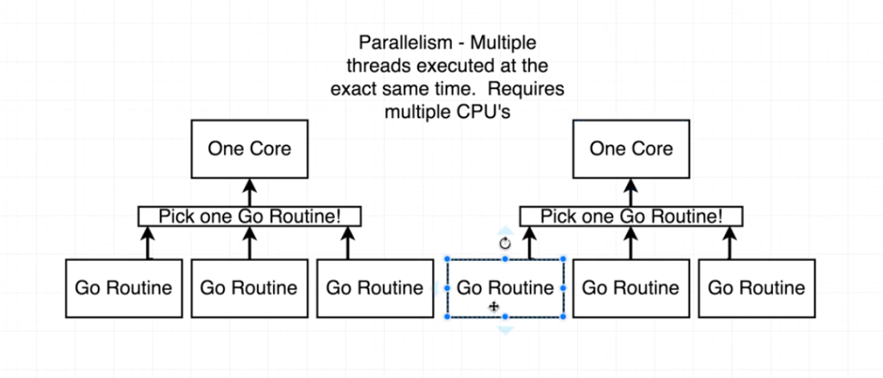

Mutex:

* + It’s a lock that the application is going to honor
  + A mutex is lock or unclock
  + If mutex is locked and someone tries to manipulate that value, then it has to wait until that mutex is unlocked and they can obtain the lock..
  + Doing this we can protect the parts of our code so that only one entity can manipulate that code.

* + Rwmutex: many can read the data but only one can write it.

--------------------------------------------------------------------------------------------------------

**Channels**:

* + Channels helps to synchronize two go routines.
  + A way for goroutines to communicate with each other.
  + A channel is like a pipe to send and receive a message.
  + An arrow pointing into the channel will send the message.

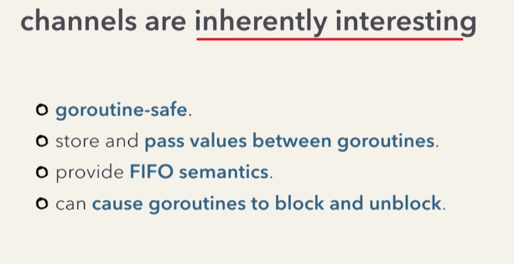

* + To use it:
  + Make a channel using the make function.

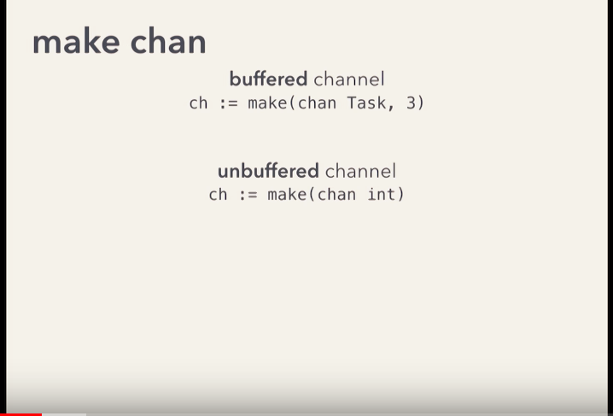

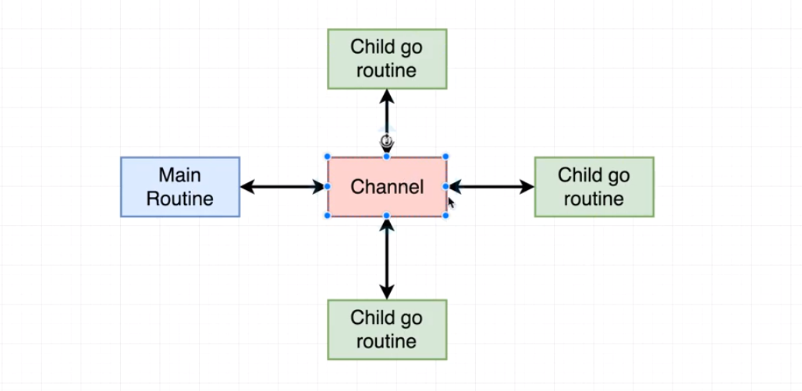

* + Send channel with the goroutine call.
  + Make goroutine definition to accept a channel as an argument.
  + Channel type can be anything, string, int etc.
  1. **Arrow pointing into the channel name will send the message to the channel.**
  2. **Arrow coming out of the channel name will help to receive the message from the channel**
  + This sending and receiving a message with channels is a blocking operation. The receiver needs to wait until there is some value available for receive. And when we are sending a message, it will wait until a receiver is ready to receive.
  + Channels are typed, that is data passed into a channel can only be a same type. For example if we create a channel of type in string we can only accept and return string types.

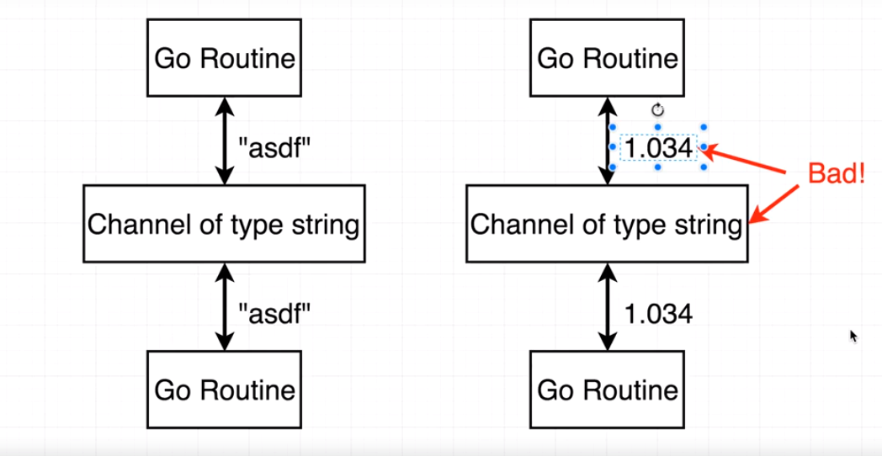

* + 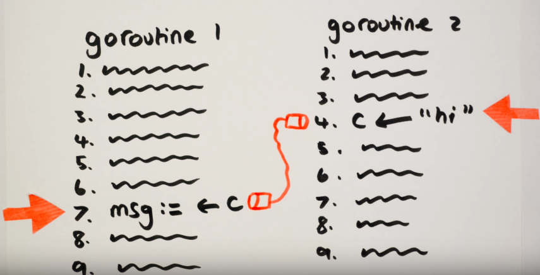
  + Goroutine 1 will wait at step 7 for goroutine 2 to send something.
  + Groutine 2 will wait at step 4, until goroutine 1 is ready to receive the message.

**Channel Directions/ Sending receiving data in channels:**

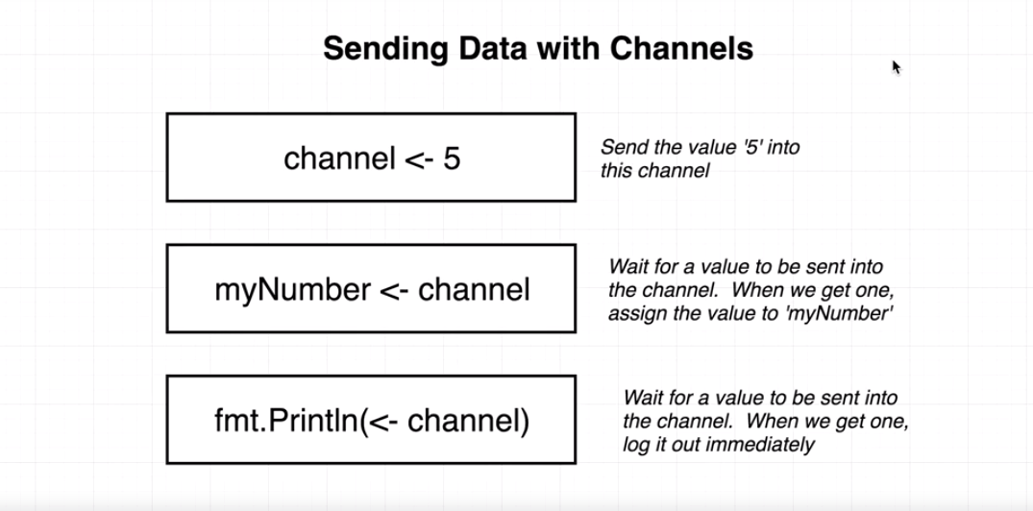

* + We specify the direction on the channel type.
  + This restricting it to either sending or receiving.
  + Below the code is receiving from a send only channel. This will give compiler error

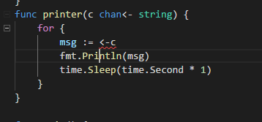

* + Sending to receive only type will also give error:

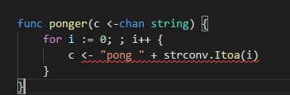

* + A channel that does not have any restrictions is called a bi directional channel.
  + Looping over a channel with range. Here range will look into the channel 'c' and wait for some message

To be received. Once it receives some message, the it will assign the message to l and starts the loop.

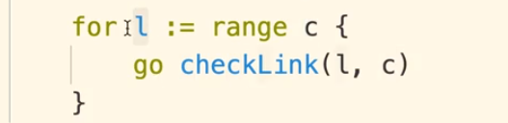

**Buffered Channel:**

* + A buffered channel is like an asynchronous channel, where sending and receiving a message will not be blocked until the buffer is full.
  + c:= make(chan int, 2)

**Deadlock**:

* + A deadlock error can happen is one goroutine is waiting to receive messages, but the other goroutine has finished execution.
  + 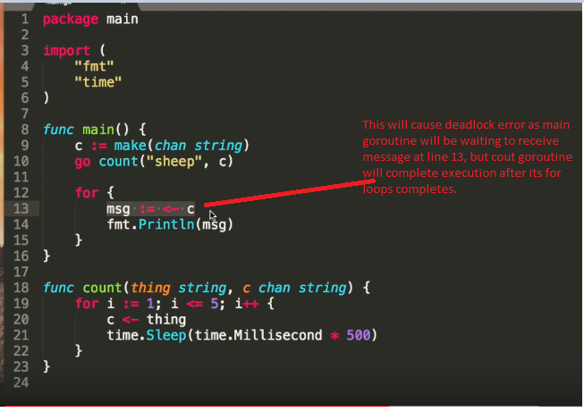
  + Here Main goroutine is waiting to receive some message that it will never get as count goroutine has finished execution. This will cause deadlock.
  + **GO is only able to identify the deadlock problem only at runtime.**
  + To solve this, as a sender we can close a channel when we don't have anything to send ( **Note : as a receiver we should not close a channel)**
  + 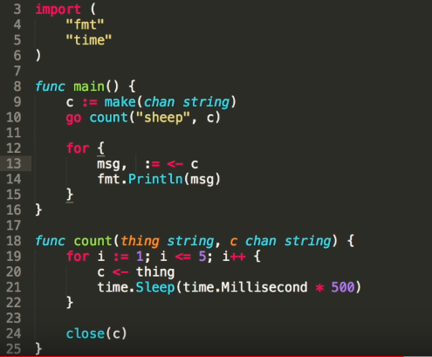
  + Here the count goroutine (sender), closes the channel at the end.
  + At the receiver side, we can see if the channel is open or not. This is possible because when receiving a channel we can provide a second around the takes value about the channel being opened or closed.

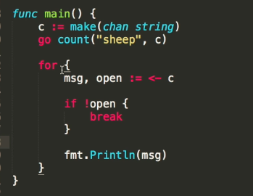

* + A better way to use channel without being worried if its closed is to iterate over the value of the channel.
  + This iteration happens until the channel is not closed.

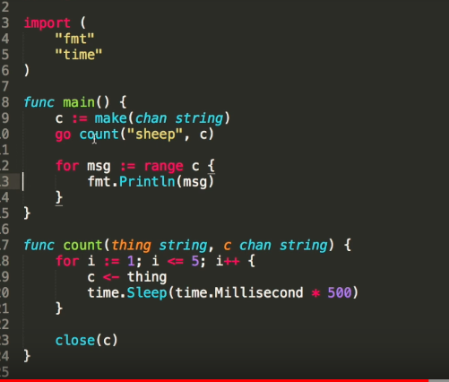

-Simple deadlock example:

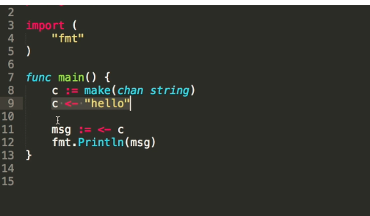

* + Here, the channel receiver at line 9 will wait for the sender (at line 11) and we will get a deadlock.
  + We can use buffered channels to avoid blocking and make things run faster
  + A buffered channel can be created by providing the buffer capacity. This channel can send messages and won't block (if there are no receivers) until the buffer is complete.
  + For example:
  + 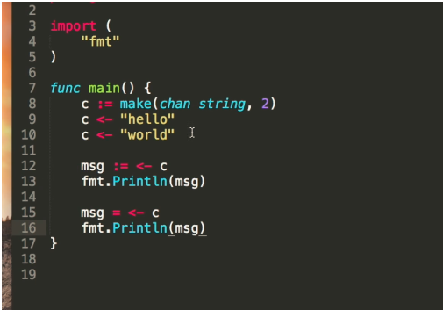
  + This channel 'c' has a capacity of 2, that is' it can send two messages and wait for receivers without blocking.
  + But once the buffered capacity is full, sending any new message will cause deadlock.
  + <https://stackoverflow.com/questions/22747711/what-is-the-use-of-buffered-channels-in-go>
  + 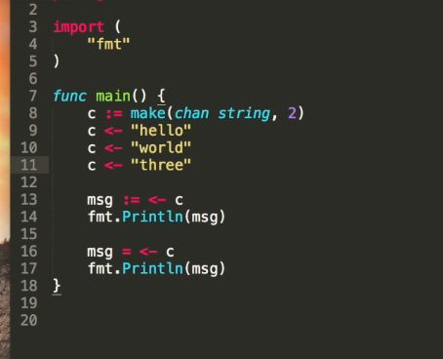
  + Sending the third message in the above code will give deadlock.

-----------------------------------------------------------------------------------------------------------------------------

**Select** :

* + Using select we can receive message from which ever channel is available.
  + It works like a switch but for channels.
  + For example:
  + 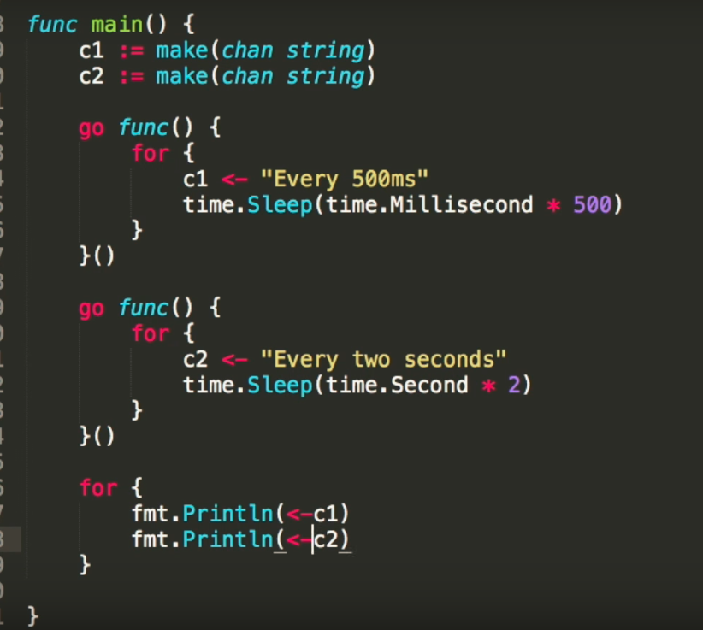
  + Here we have two goroutines and two channels.
  + Each goroutine runs infinitely and sends messages to a particular channel after 500 ms and 2 seconds respectively.
  + Here "fmt.Println(<-c2)" in the main goroutine is blocked for 2 seconds, and this slows down the c1 message receive as well, as its blocked.
  + This is slowing down the first goroutine.
  + In such situations we can use 'select'
  + Select allows us to receive messages from whichever channel is ready.
  + 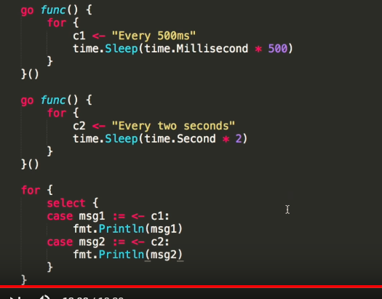

------------------------------------------------------------------------------------------------------------------------------

How channels Work internally:

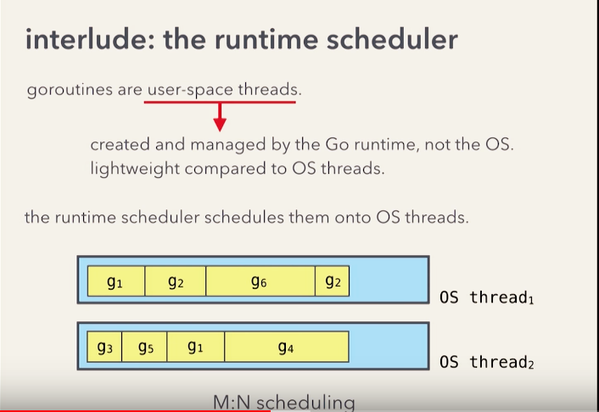

goroutines are user-space threads.

They are managed and run by the go-runtime and not by the os.

User space thread are less expensive with respect to resource consumption and scheduling overhead.

These user space threads have to run on os threads which is done by Scheduler by using an MN scheduling model.

Schedular multiplexes some number of goroutines and a few os threads

-------------------------------------------------------------------------------------------------------------------------------

Error Handling in Golang:

* + Go does error handling differently. Not using try catch
  + 4 common ways for

-------------------------------------------------------------------------------------------------------------------------------

Linting with Golang:

* + Get the third party package:

go get -u golang.org/x/lint/golint

* + Run the command 'golint ./… ' to lint current package and all the packages inside it.

Notes:

* + Defer : Defers the execution of a function until the surrounding function returns
  + 